Task ---- Creating new IAM user.

Create a new IAM user (Yourname-Pipeline) and group with policies: “AdministratorAccess”, “AWSCodeCommitFullAccess”, & “AWSCodePipelineFullAccess”.

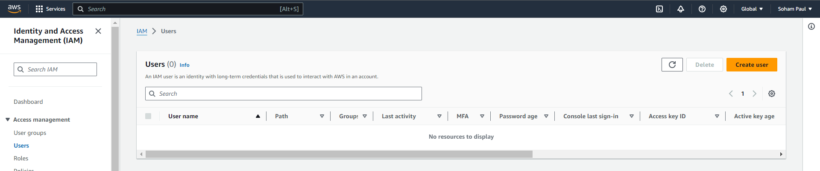

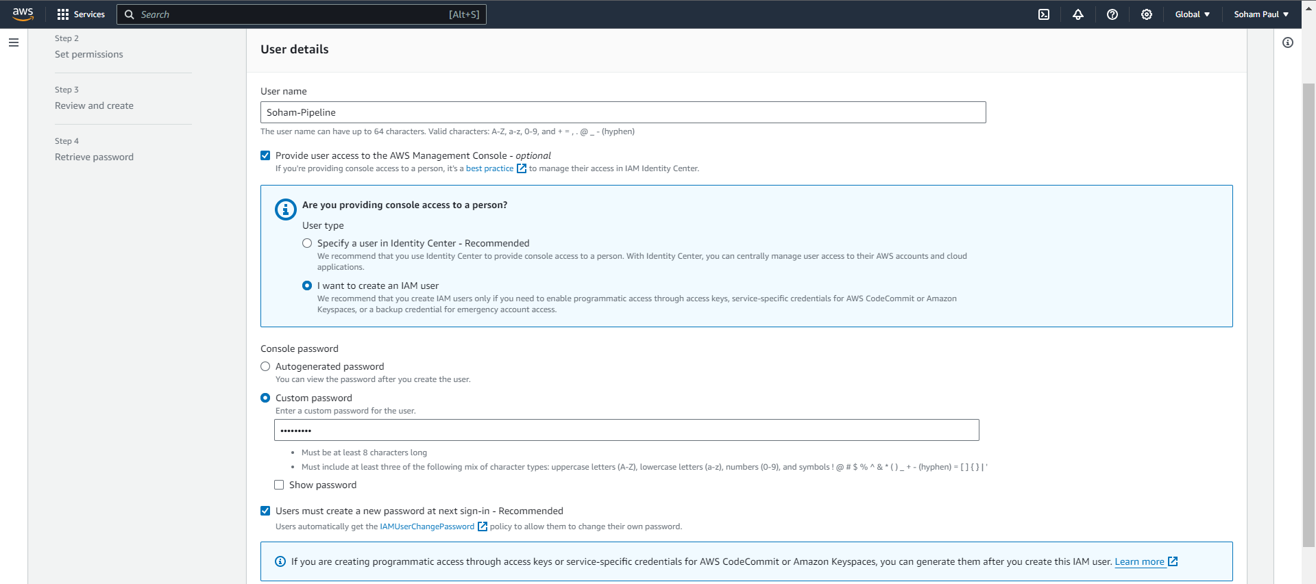

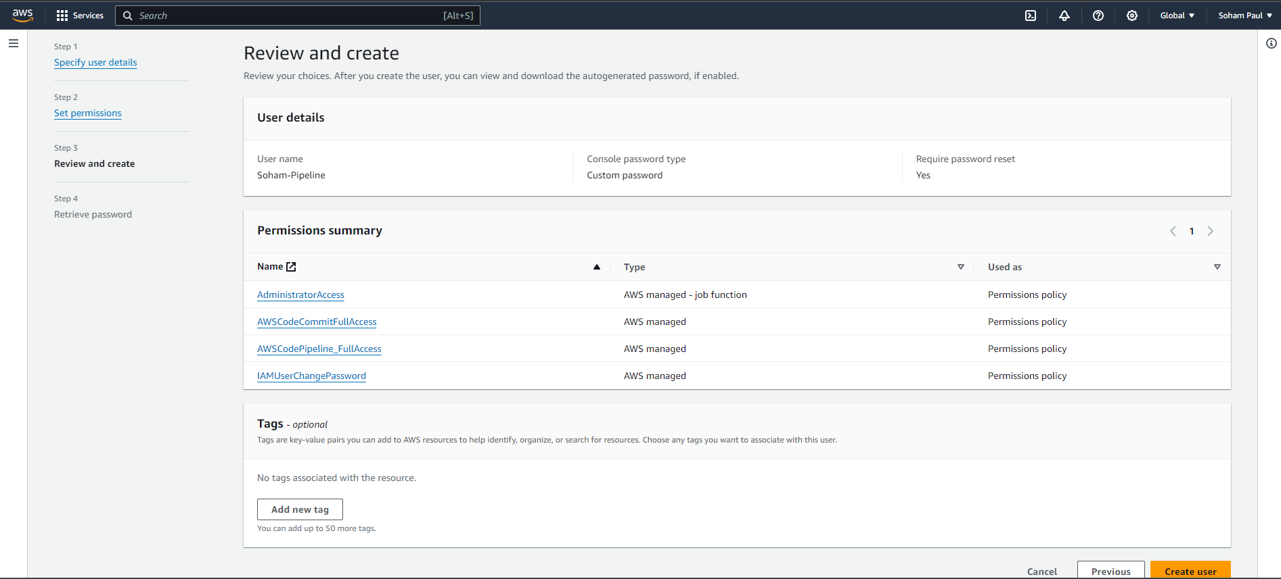

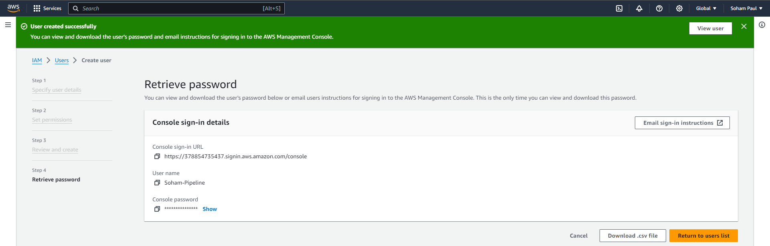

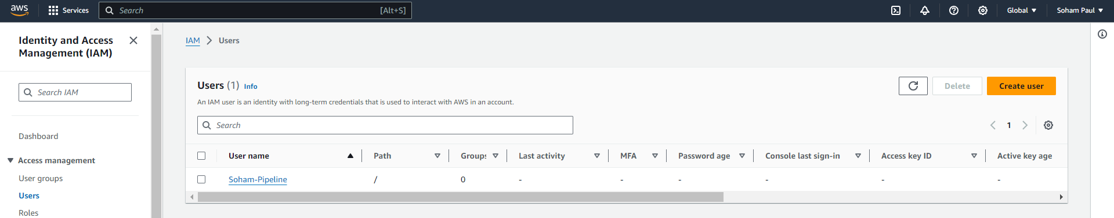

Log back in as an IAM user.

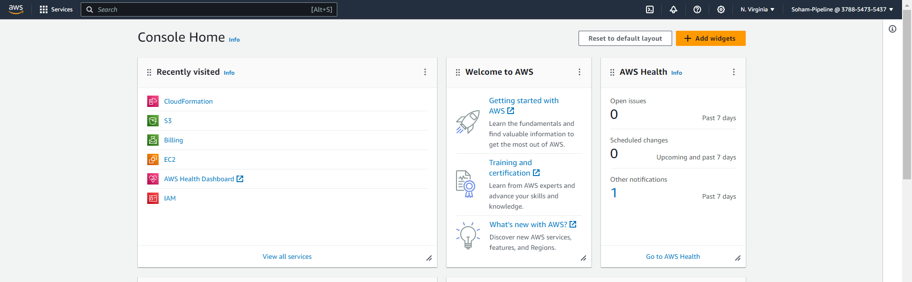

PART 1: CodeCommit - Creating a repository on CodeCommit

Step 1: Creating an Amazon CloudWatch Events to detect and react to pipeline execution state changes by sending an Amazon SNS notification.

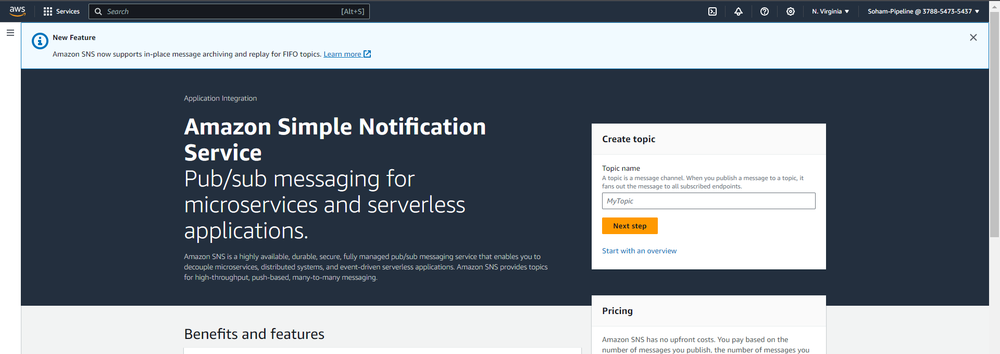

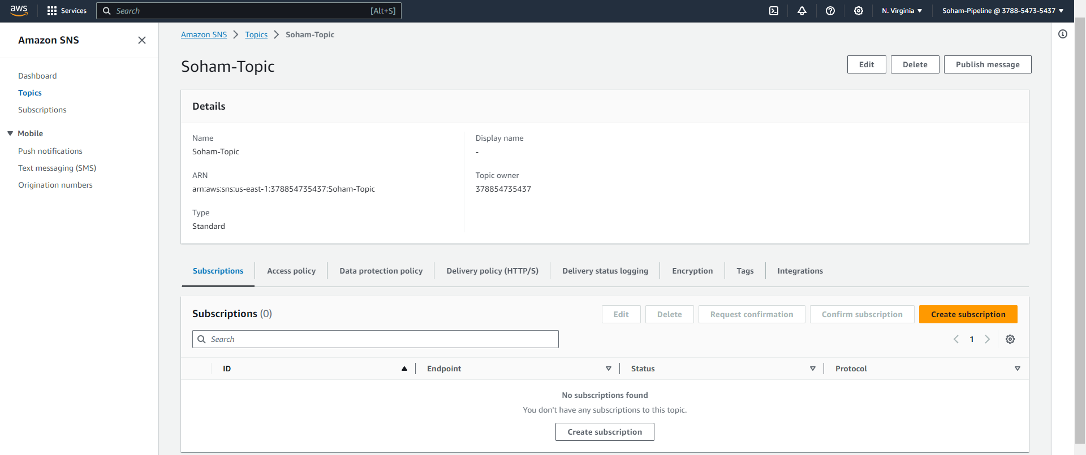

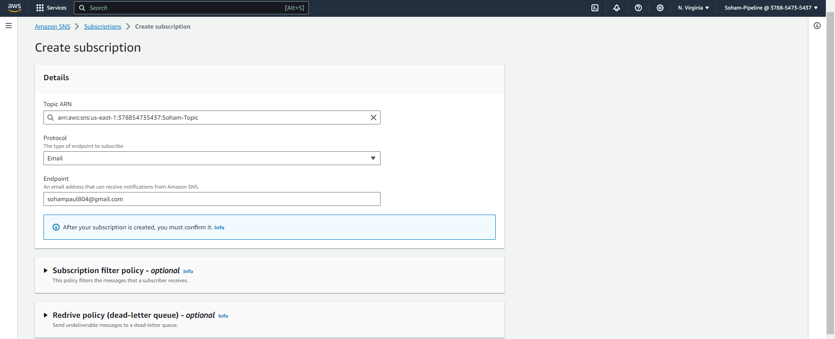

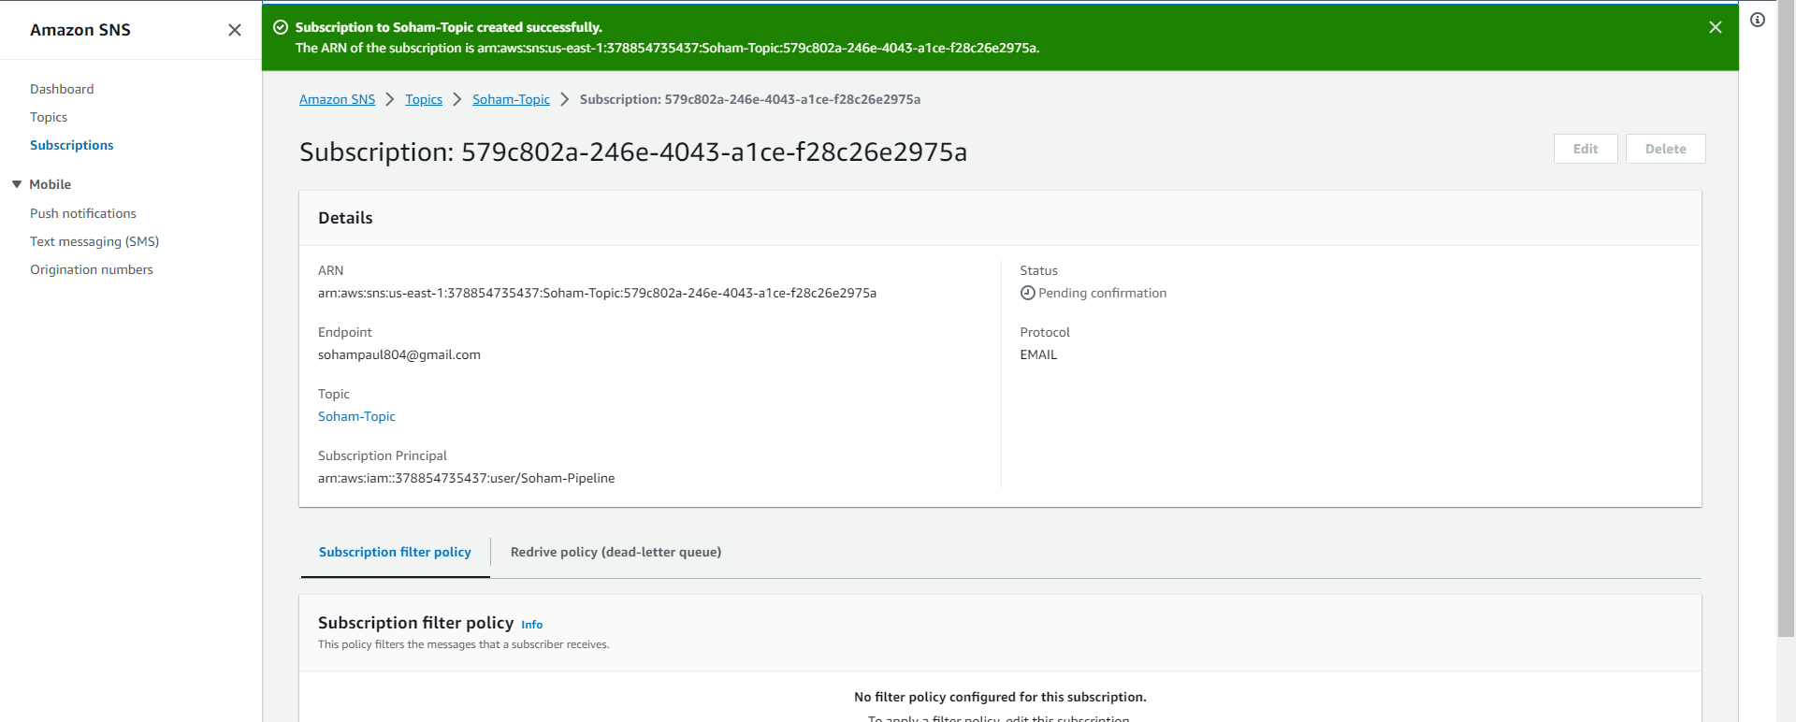

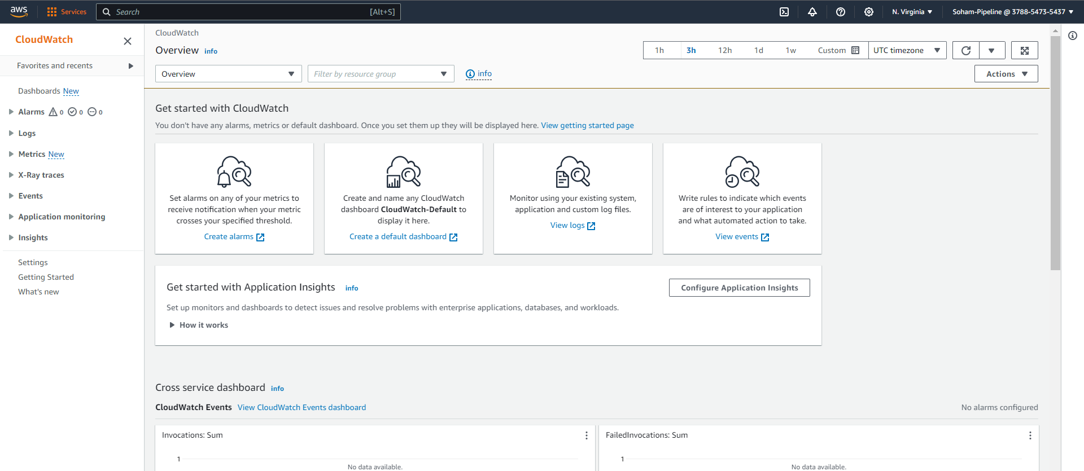

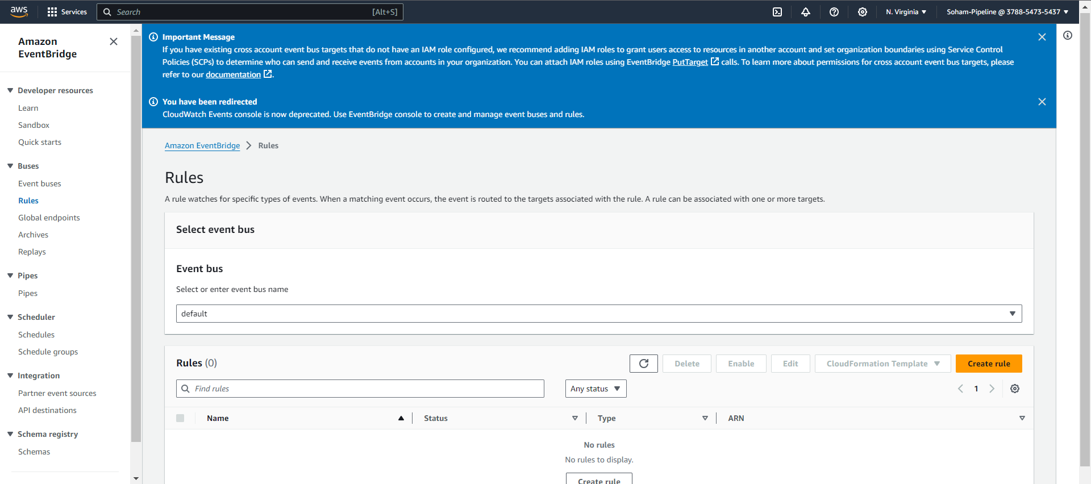

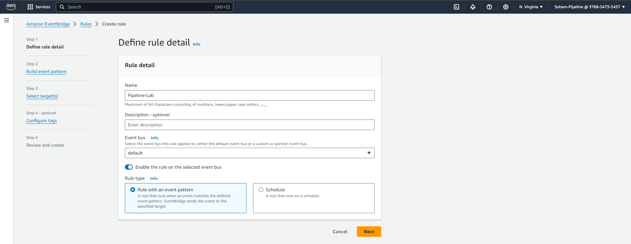

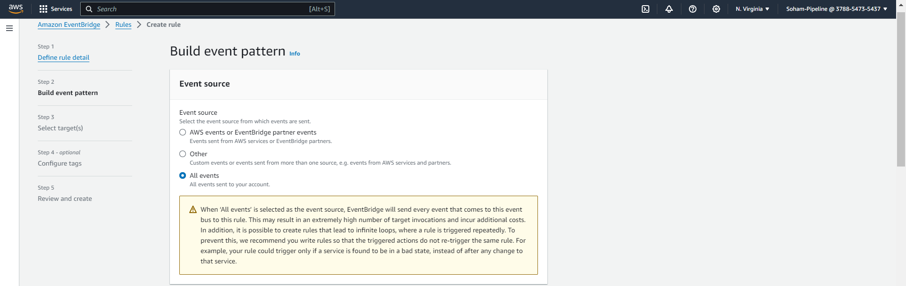

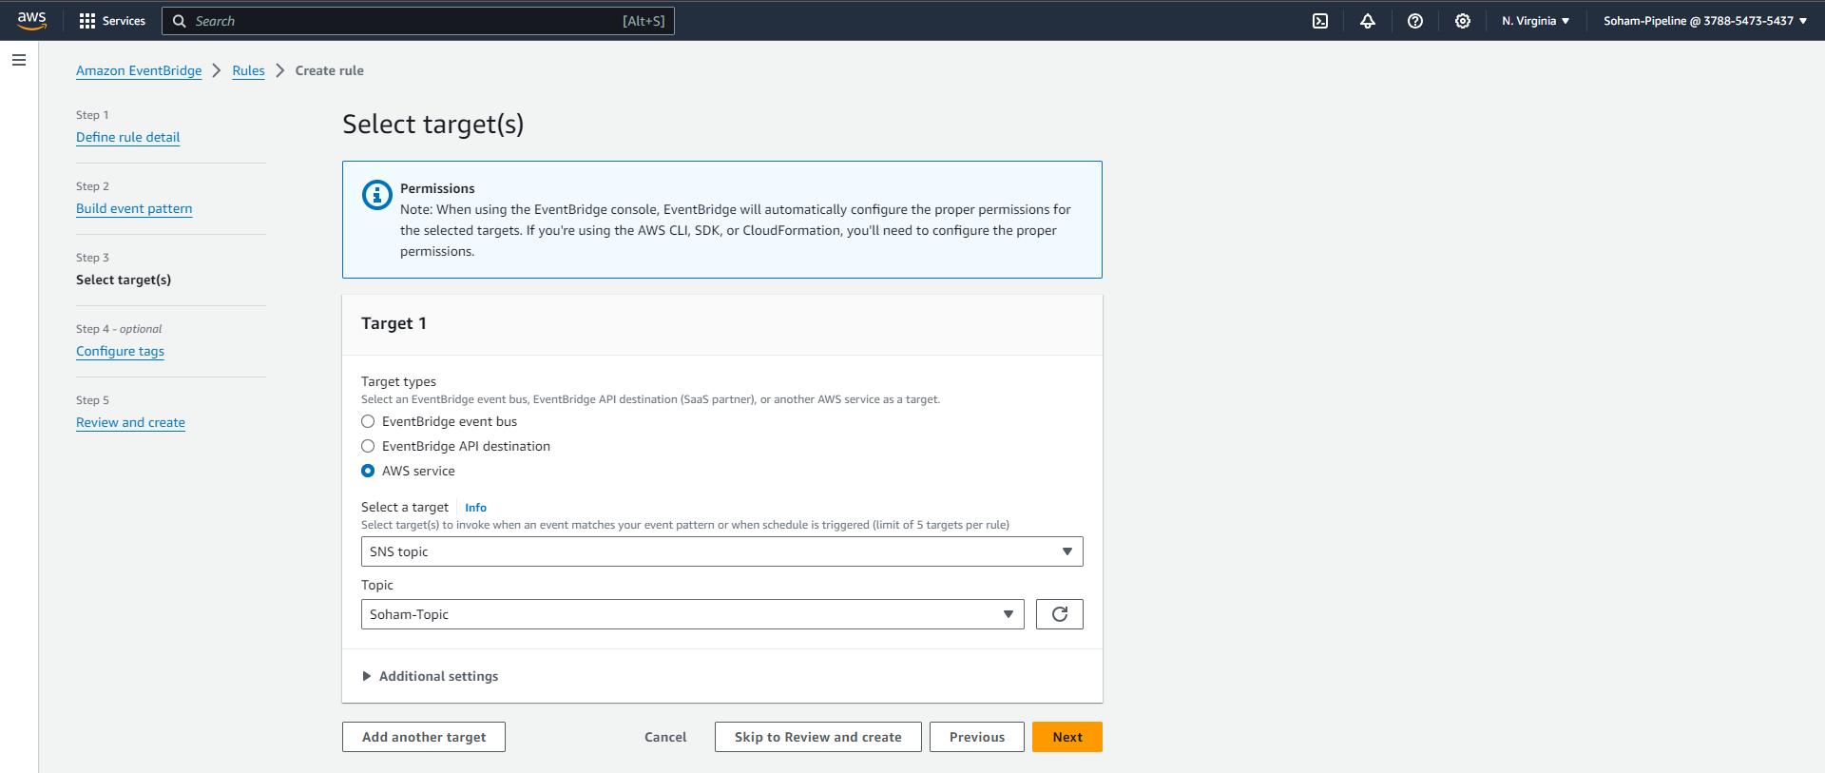

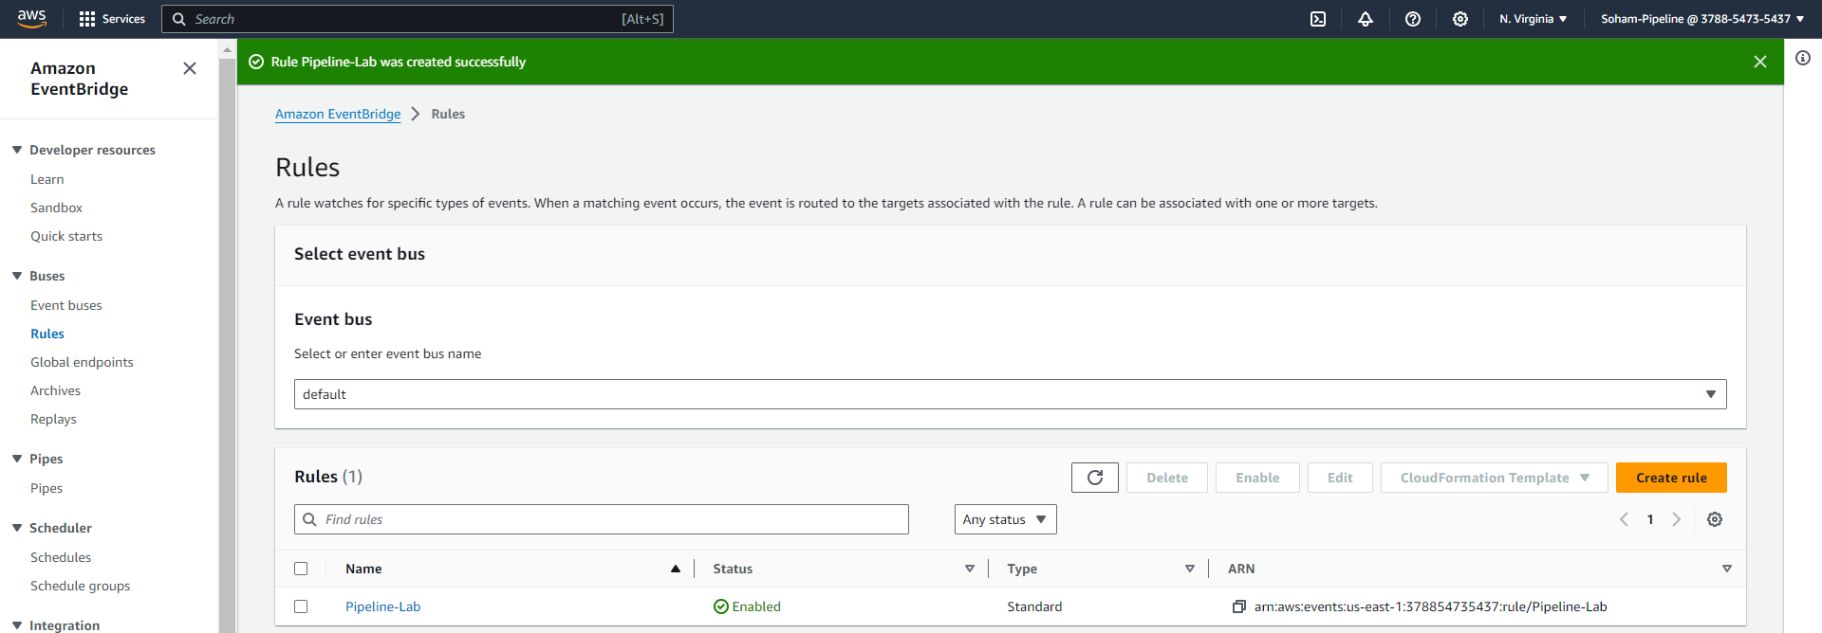

Step 2: Create a repository named <your-name-pipeline> on CodeCommit using AWS Console and connect using HTTPS

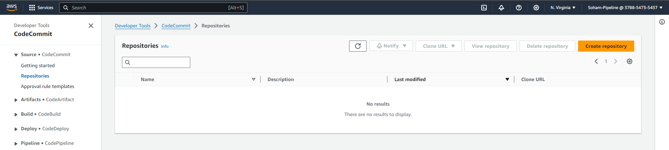

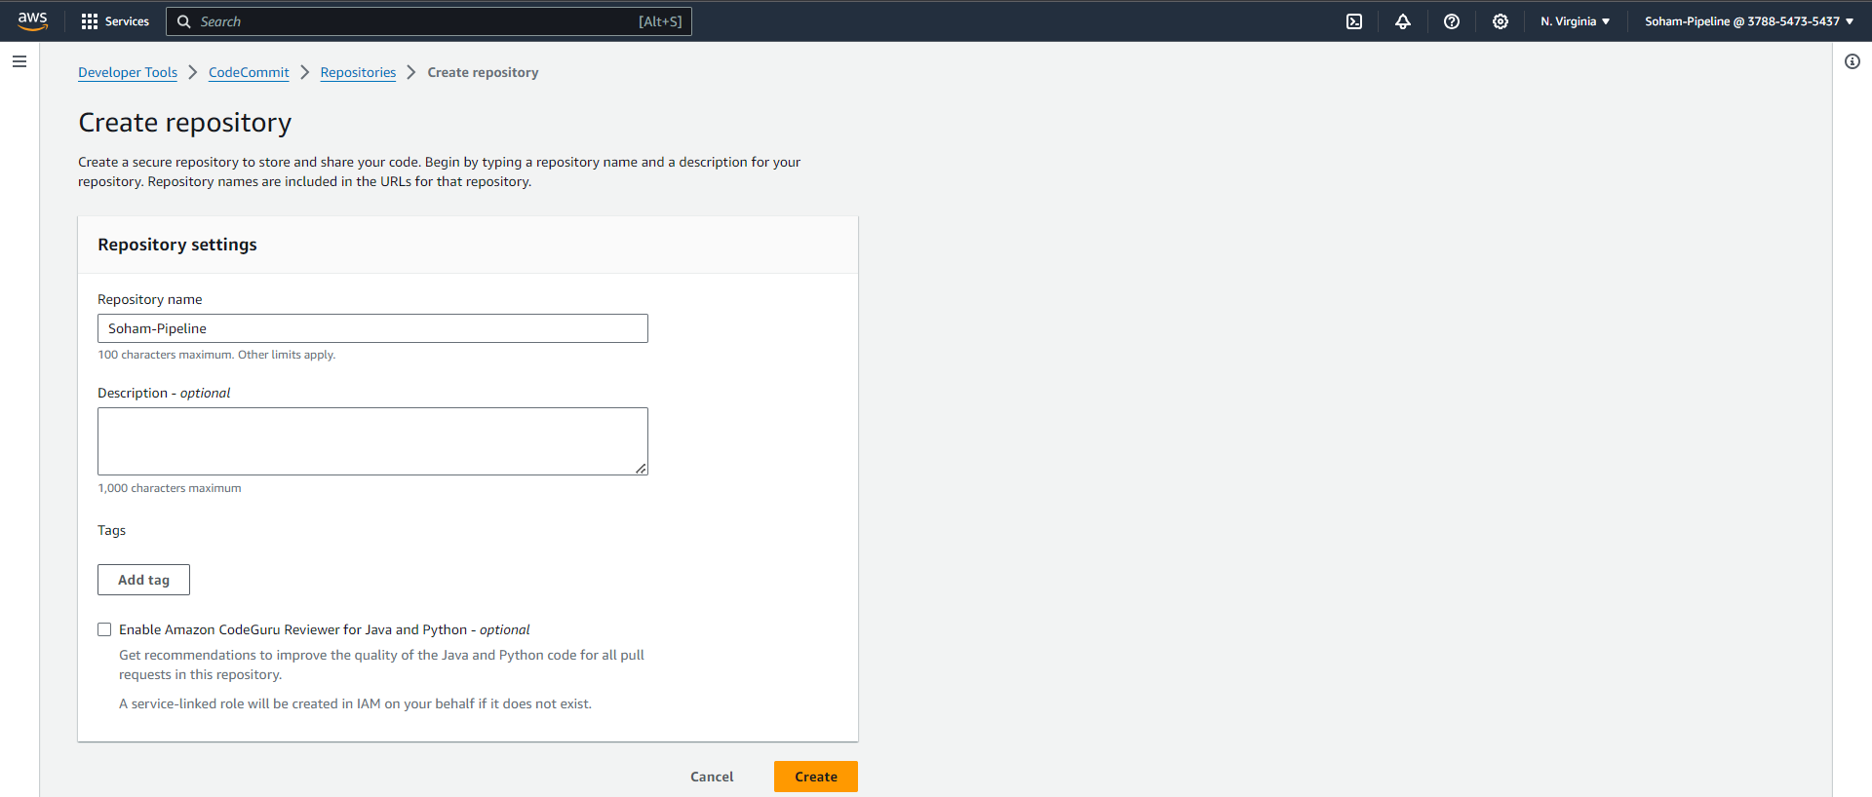

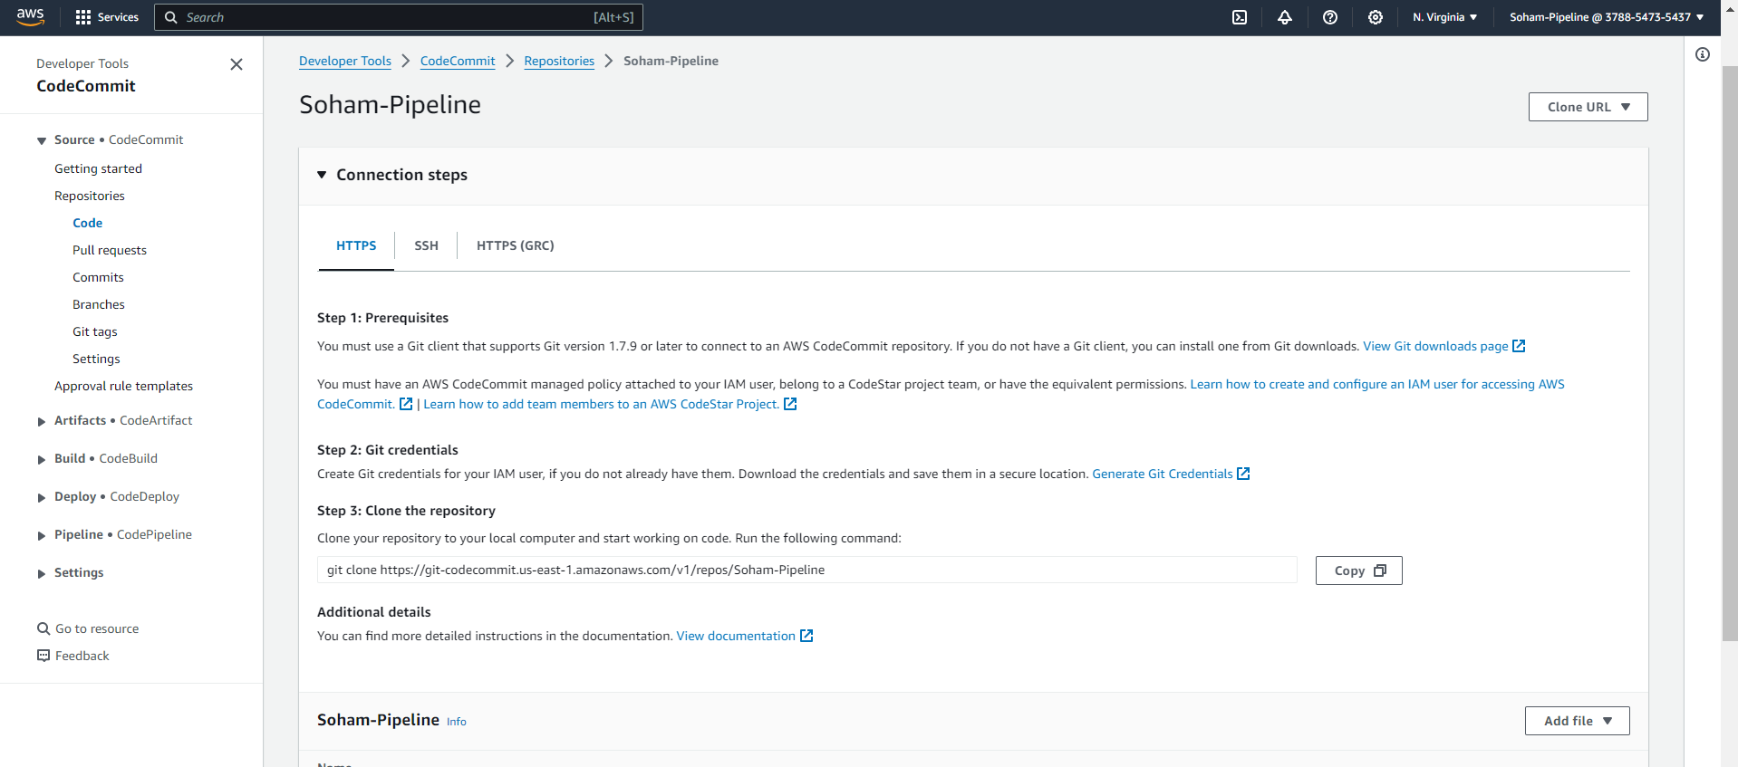

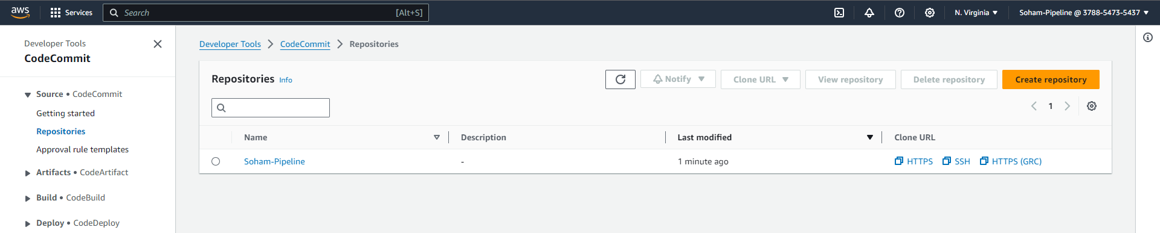

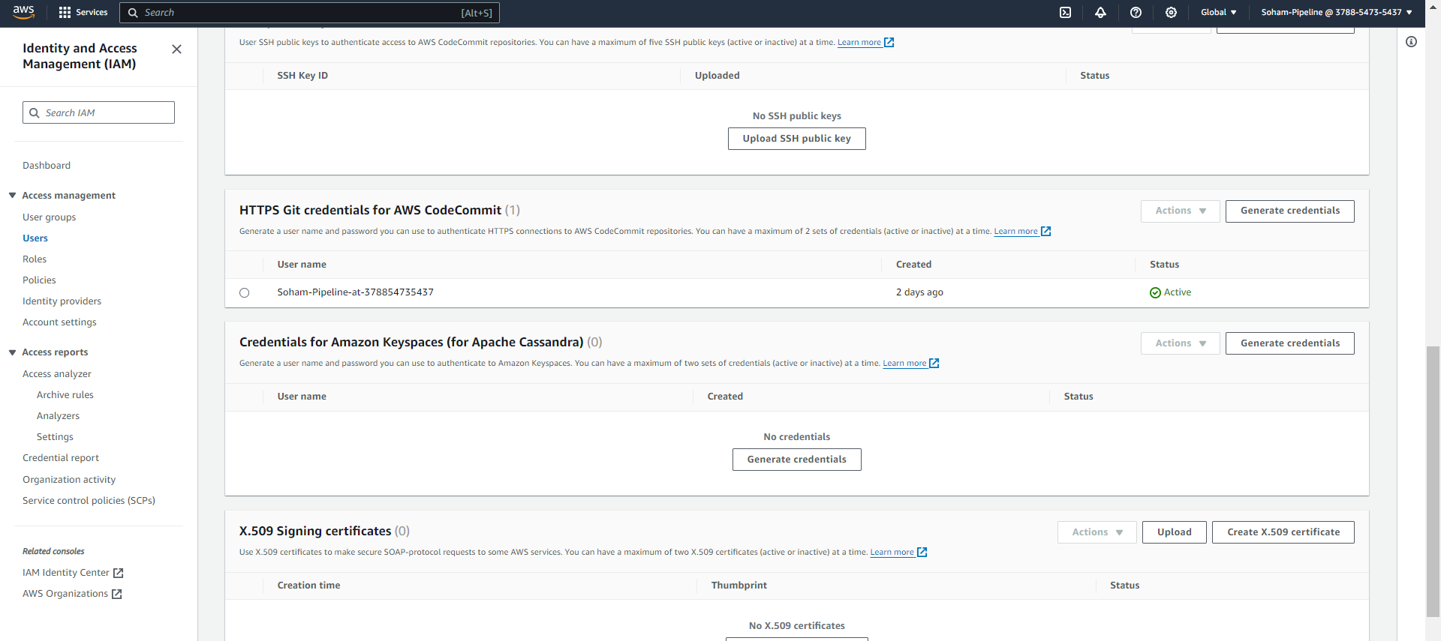

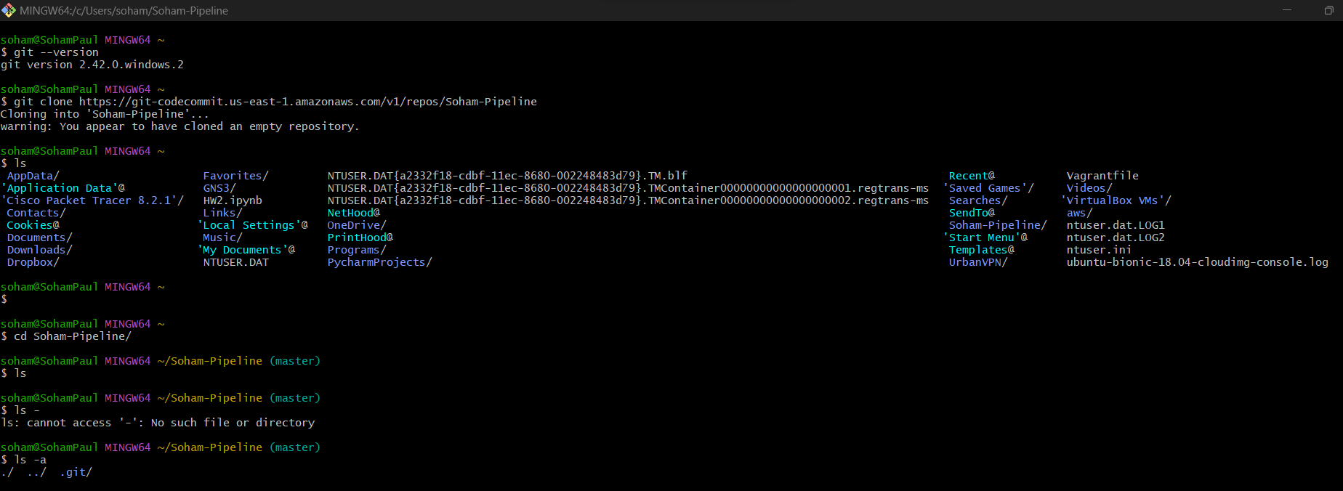

PART 2: CODEBUILD - Creating a new build in CodeBuild.

TASK 1: Create an S3 bucket named as <your-name-pipeline-lab>

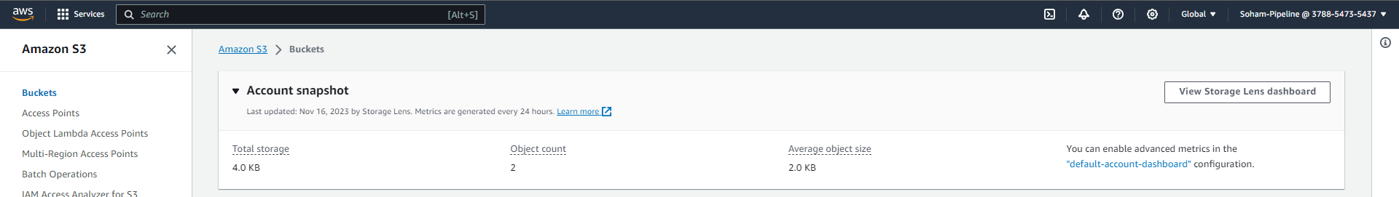

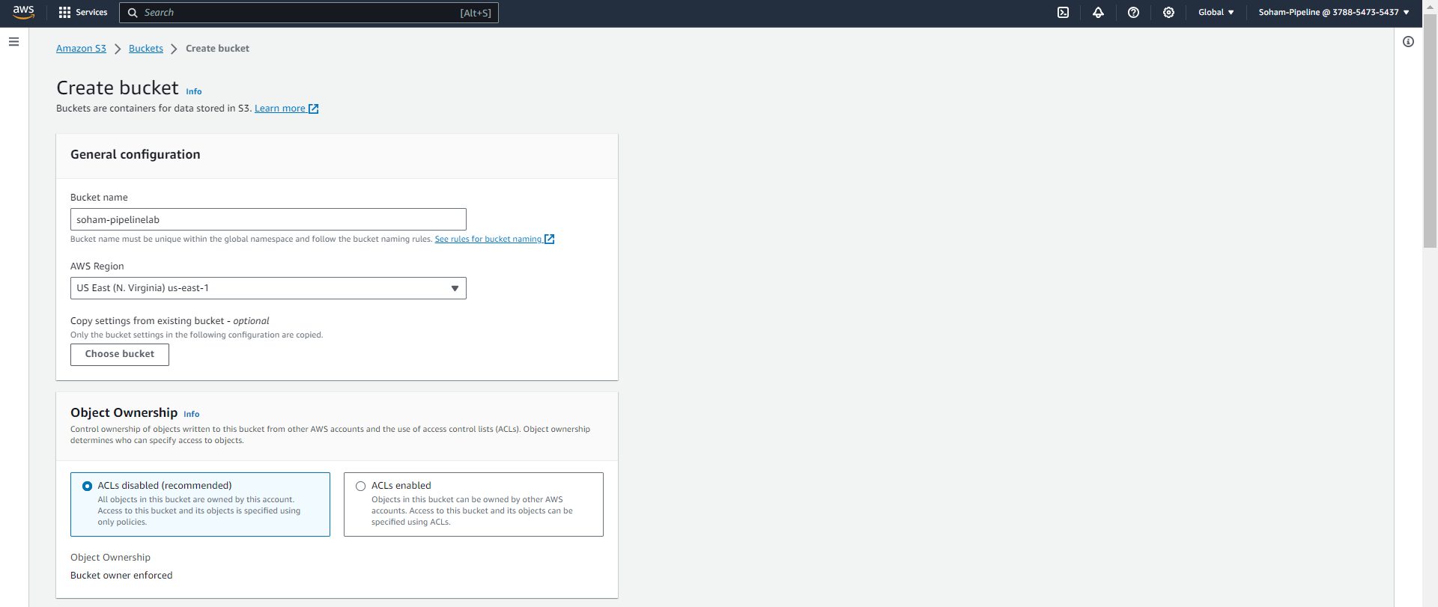

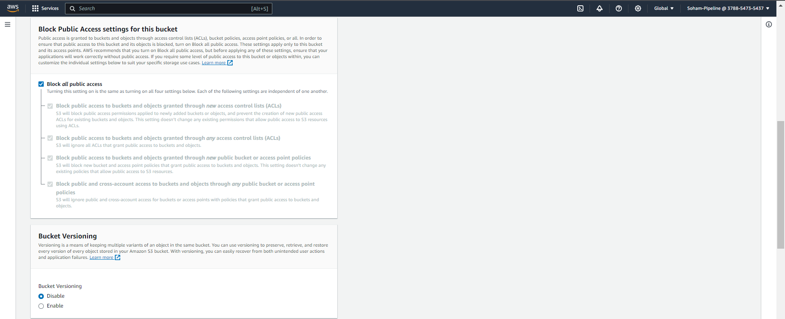

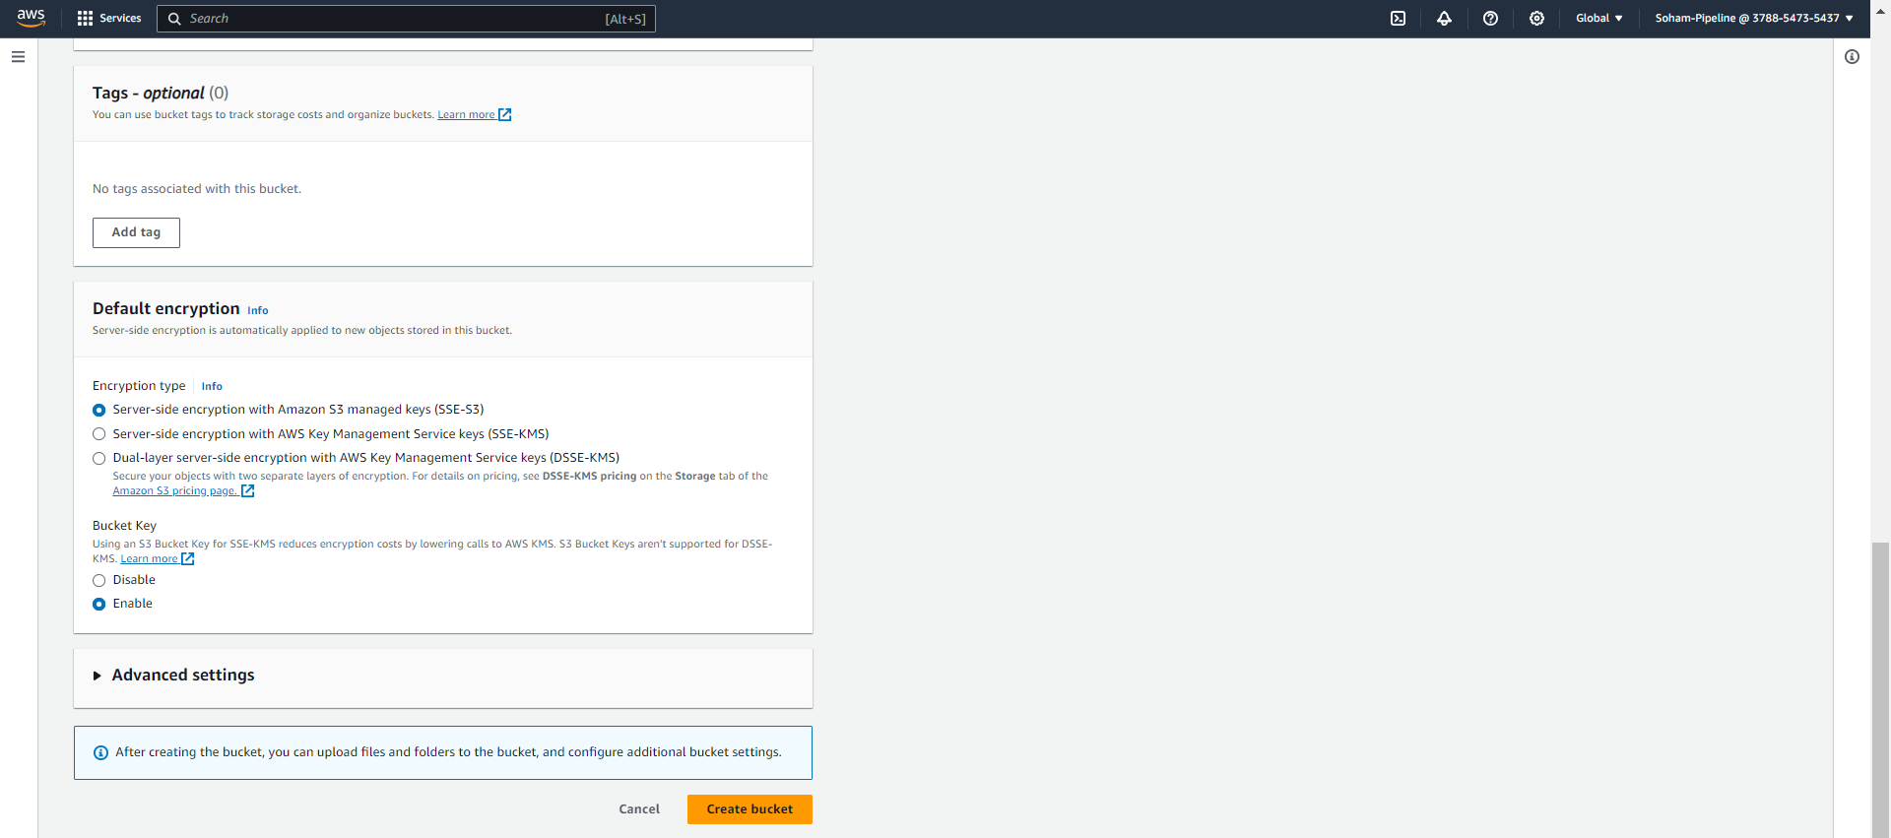

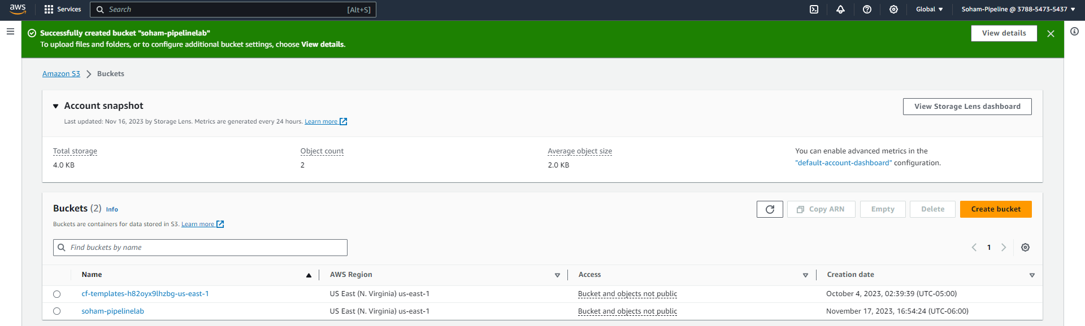

TASK 2: Create a buildspec.yml and appspec.yml file for your repository

buildspec.yaml:

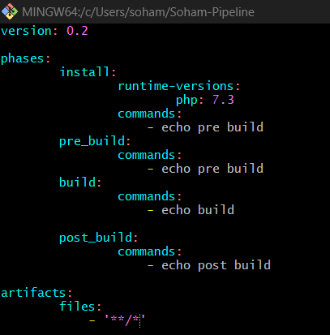

appspec.yaml:

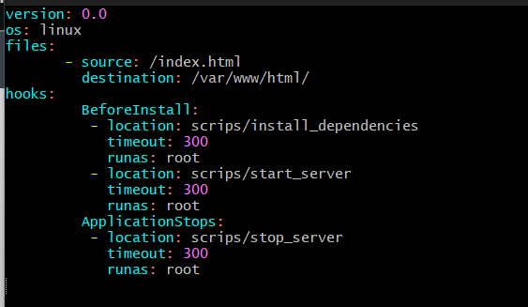

Index.html

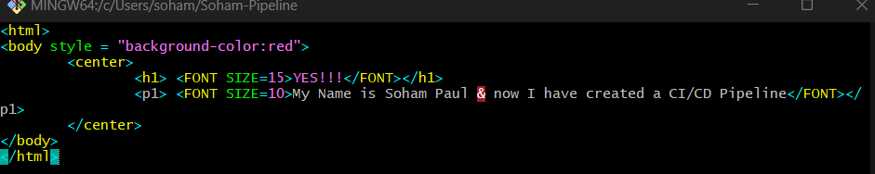

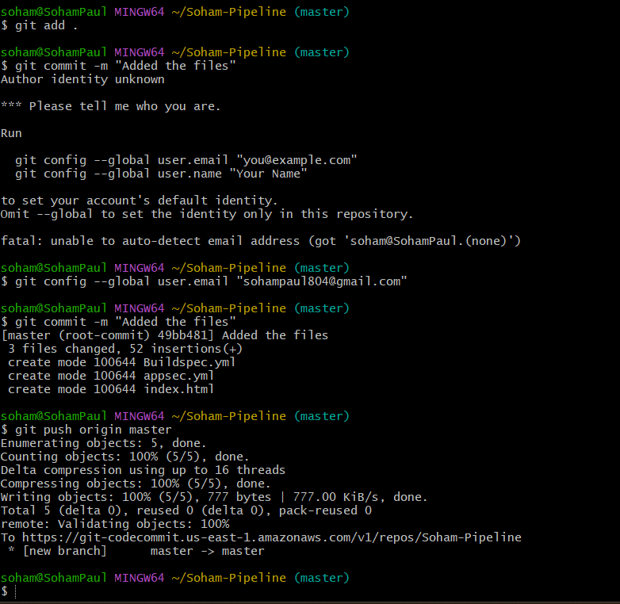

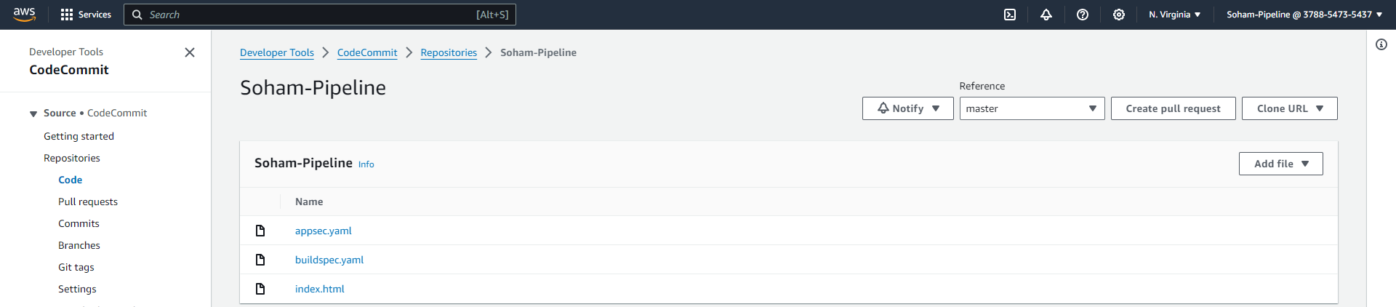

Theory questions:

**Q) What is a buildspec file, in which stage will it be used & explain the file provided in this assignment**

**Ans:** Buildspec file is linked with AWSCodeCommit which is a continuous integration service of AWS. The file format is YAML through which instructions are provided to the CodeBuild to execute commands different phases. It customizes the build process to define how the source code is compiled, tested, and prepared for the final deployment.

This file plays an important role in the Build stage of CI/CD pipeline. It performs tasks like compiling and packaging the application. It is essential to specify the detailed instruction on how the process of build will be executed.

The file provided in this assignment explains that the build specification will be 0.2, the phases syntax provides the commands that will be executed in the three phases ‘pre-build’ (The phases before the actual build process starts), ‘build’ (The phase where the main application is built) and ‘post-build’ (The phase which will be after the build is complete). This phase is also used to install the dependencies like the runtime environment which will be PHP version 7.3. The commands mentioned in each of the phases are the ones which will be executed when that phase comes.

**Q) What is an appspec file, in which stage will it be used & explain the file provided in this assignment**

**Ans:** This file is a key component in deploying applications using AWSCodeDeploy, a service which automates application deployment in EC2 instance, AWS Lambda. This file defines the deployment process on how to install, configure and deploy an application on the target environment. It is a blueprint of CodeDeploy written in YAML or JSON format.

It is utilized in software development lifecycle. Once a code has been build and tested the deployment process starts. AWS CodeDeploy references this file to orchestrate the development steps. This approach enhances automation, consistency, and reliability in the deployment process, contributing to efficient and error-free application releases.

Once the application code has been built and tested, the deployment process initiates, with AWS CodeDeploy relying on the AppSpec file as a roadmap to coordinate deployment actions. This file defines the deployment specifics, encompassing details like file mappings, pre and post-deployment scripts, and required permissions. CodeDeploy ensures a seamless deployment to the target environment by incorporating the customizations outlined in the AppSpec file. This methodical approach improves automation, sustains uniformity, and enhances the reliability of the deployment process, ultimately contributing to the effectiveness and error-free nature of application releases.

TASK 3: Create a new build in CodeBuild

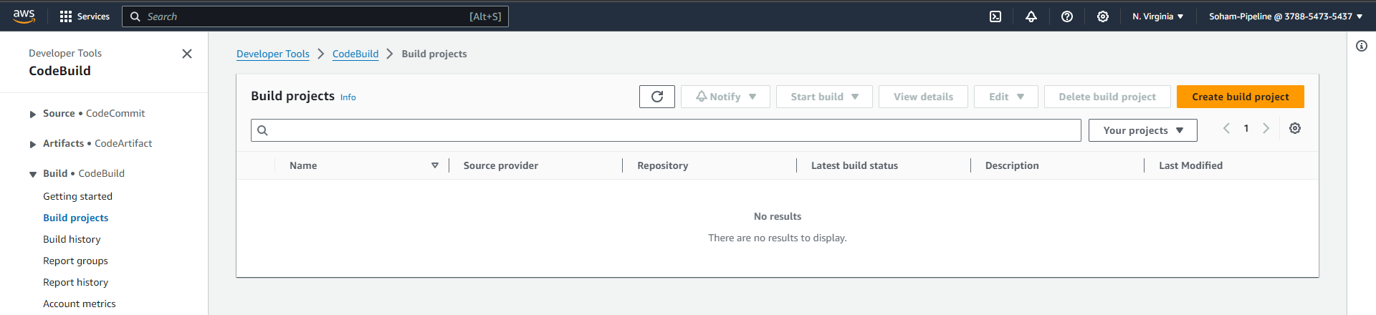

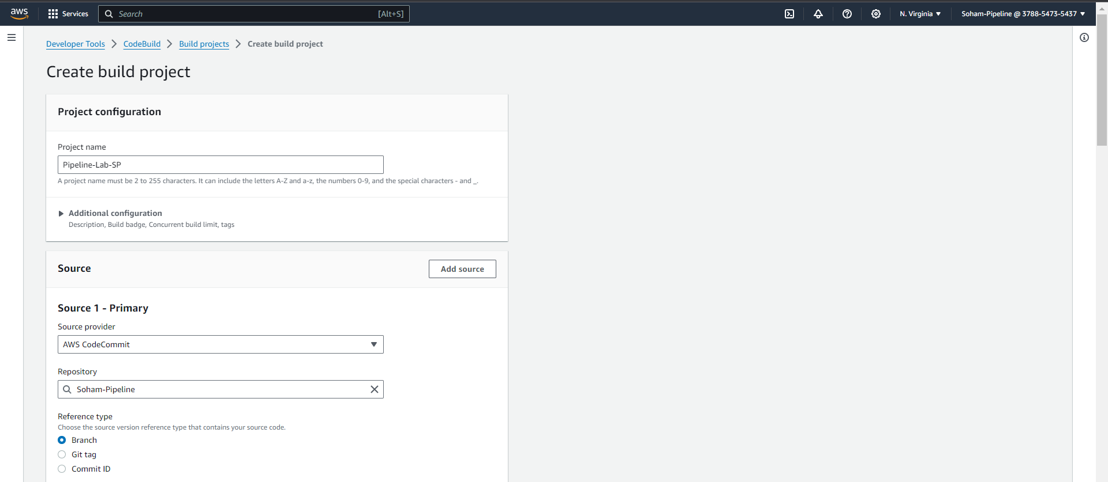

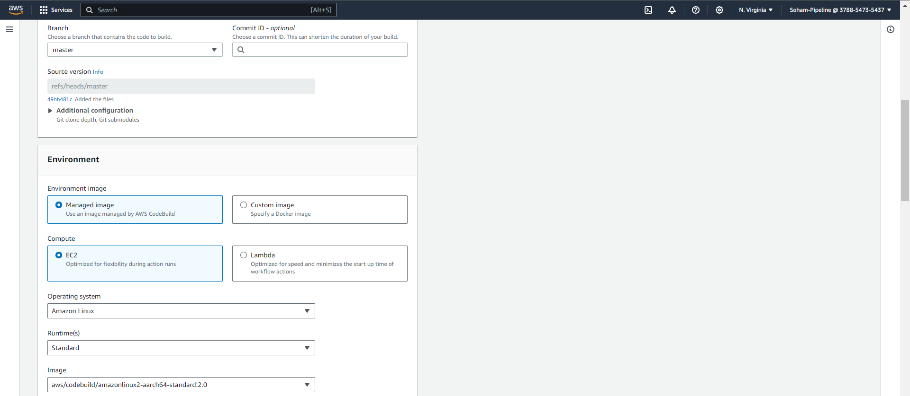

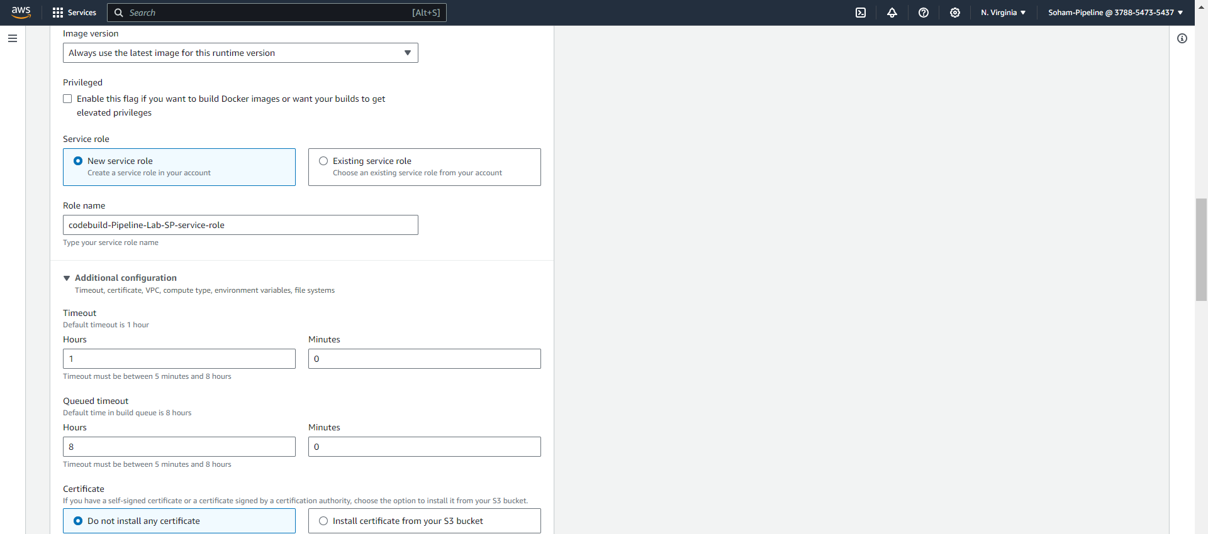

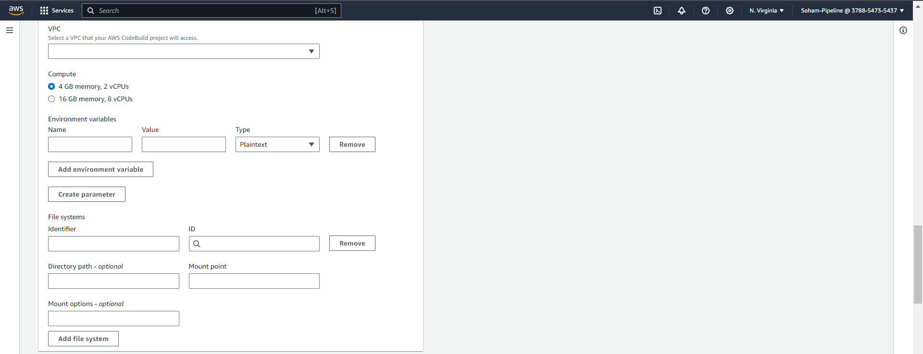

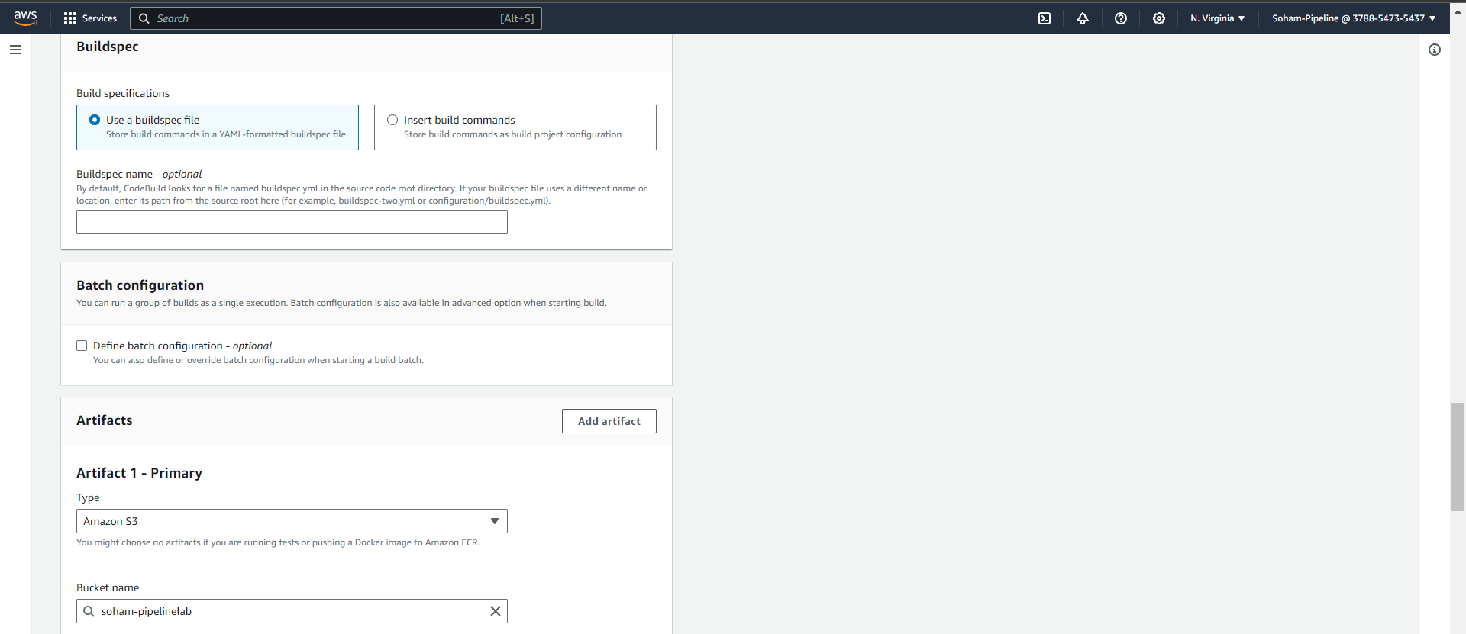

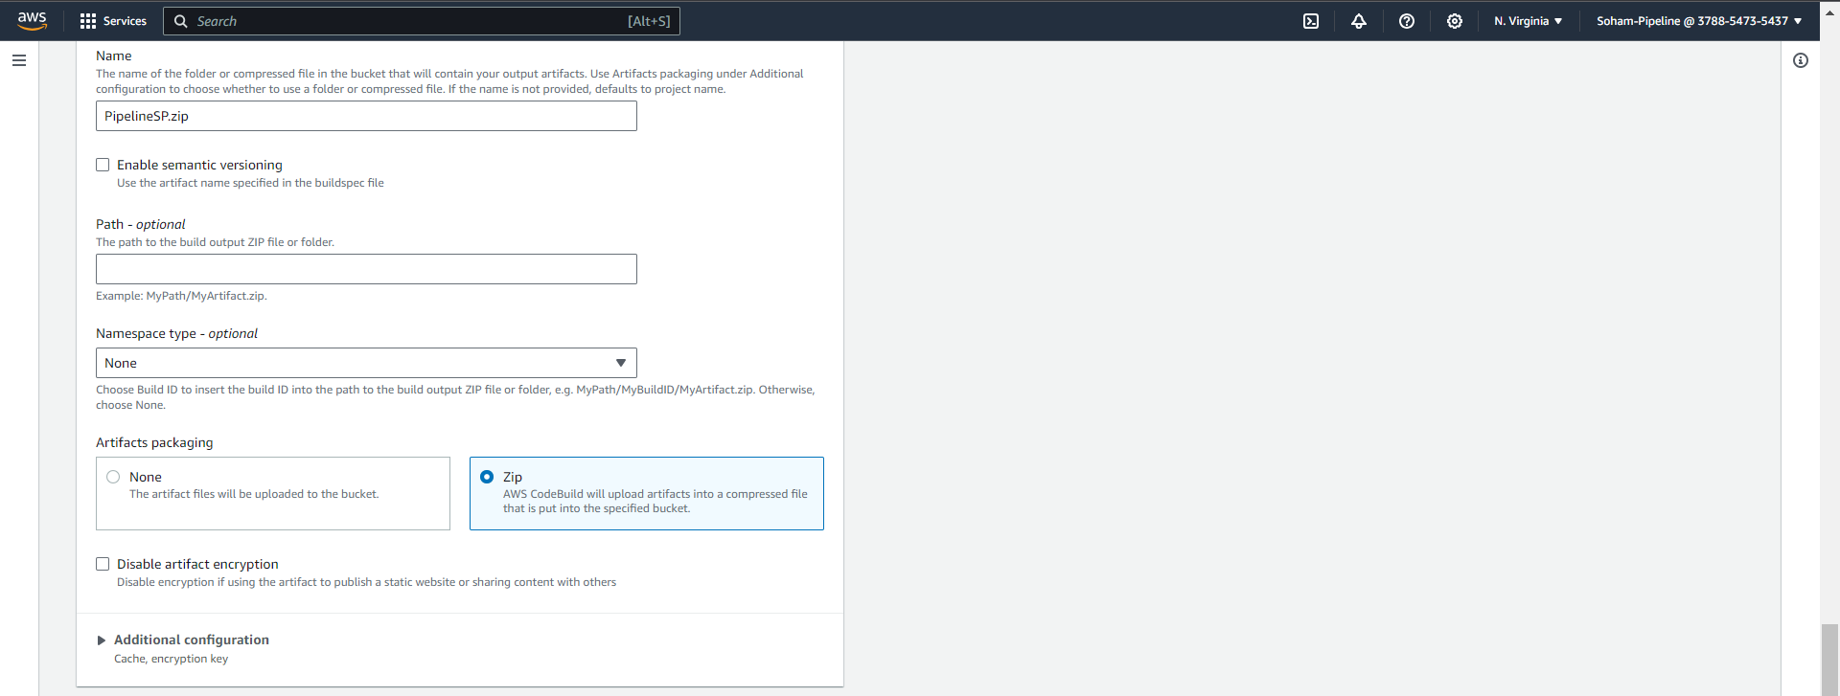

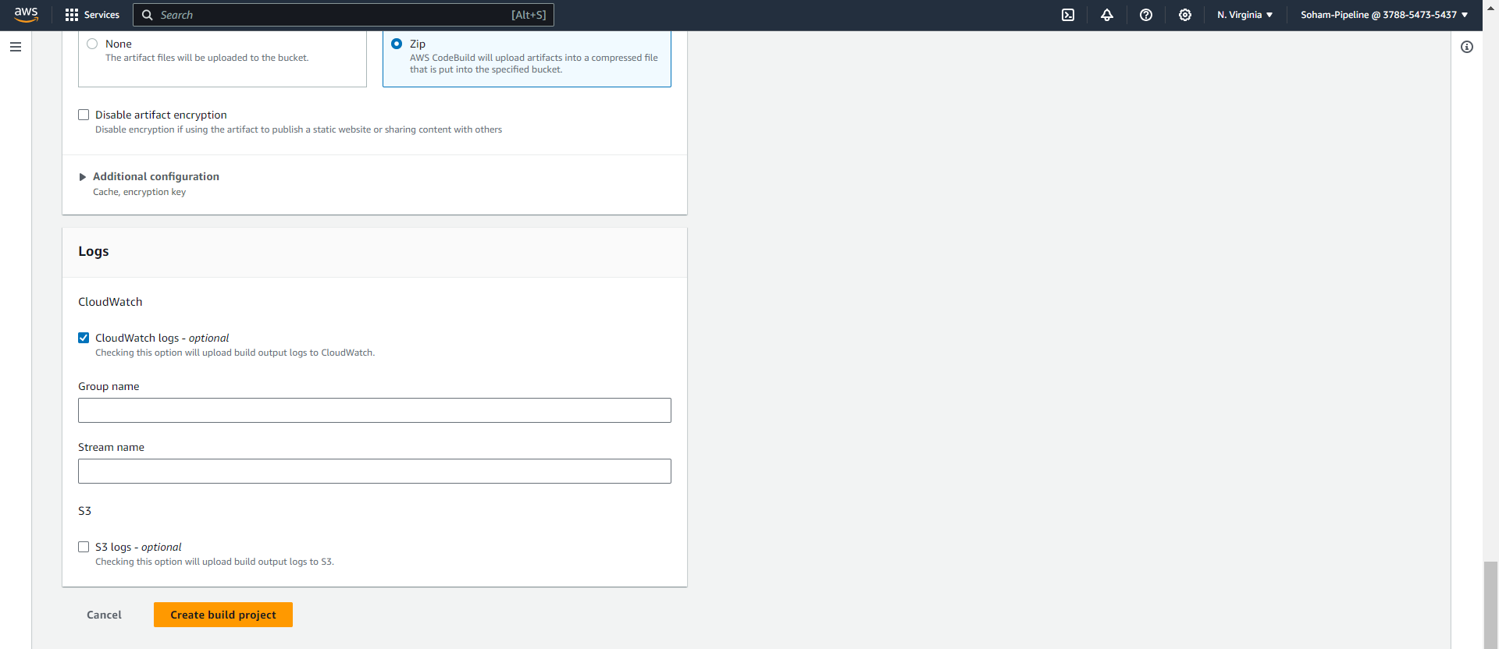

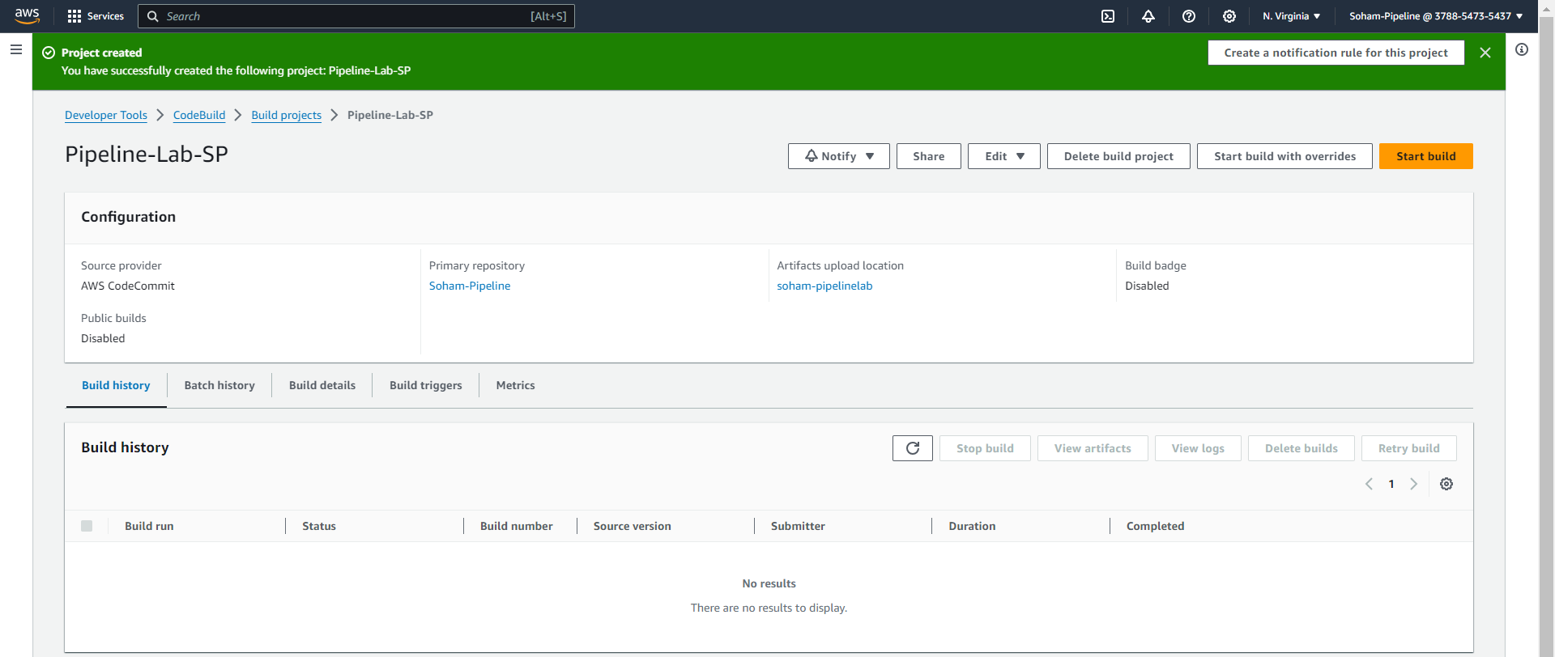

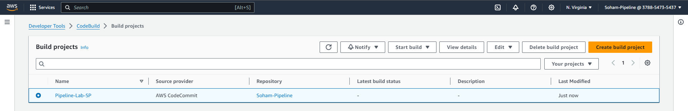

TASK 4: Start Build (ADD SCREENSHOT)

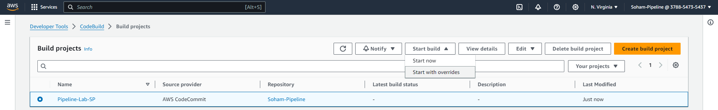

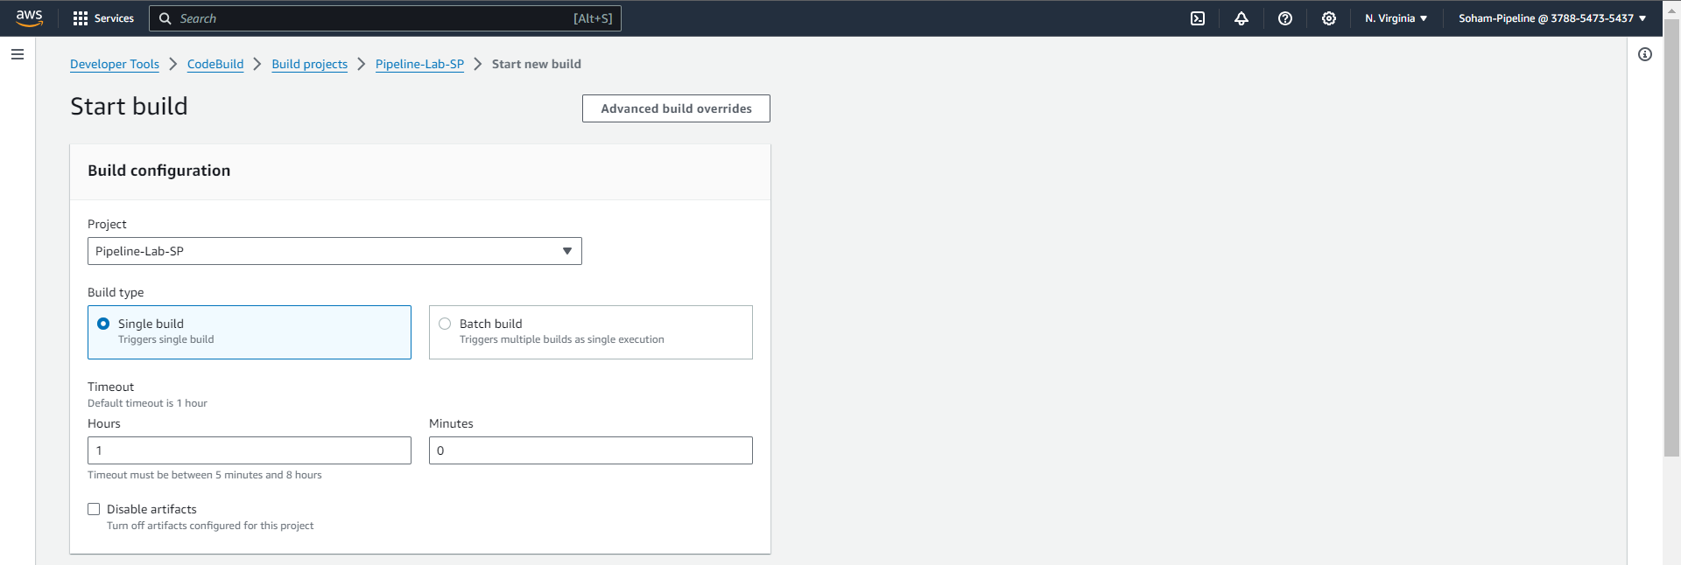

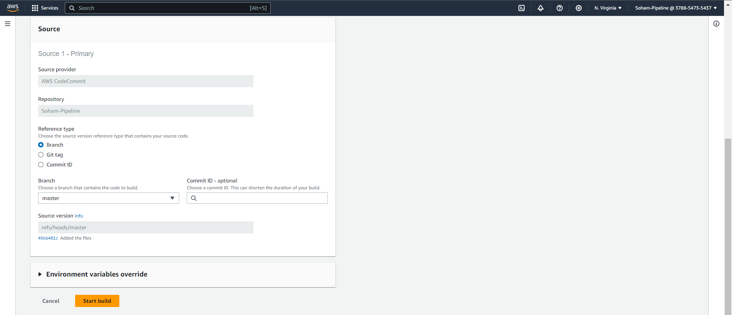

Check your build

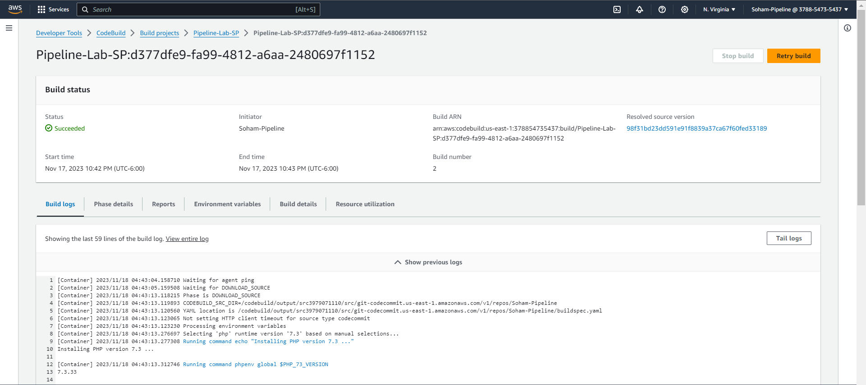

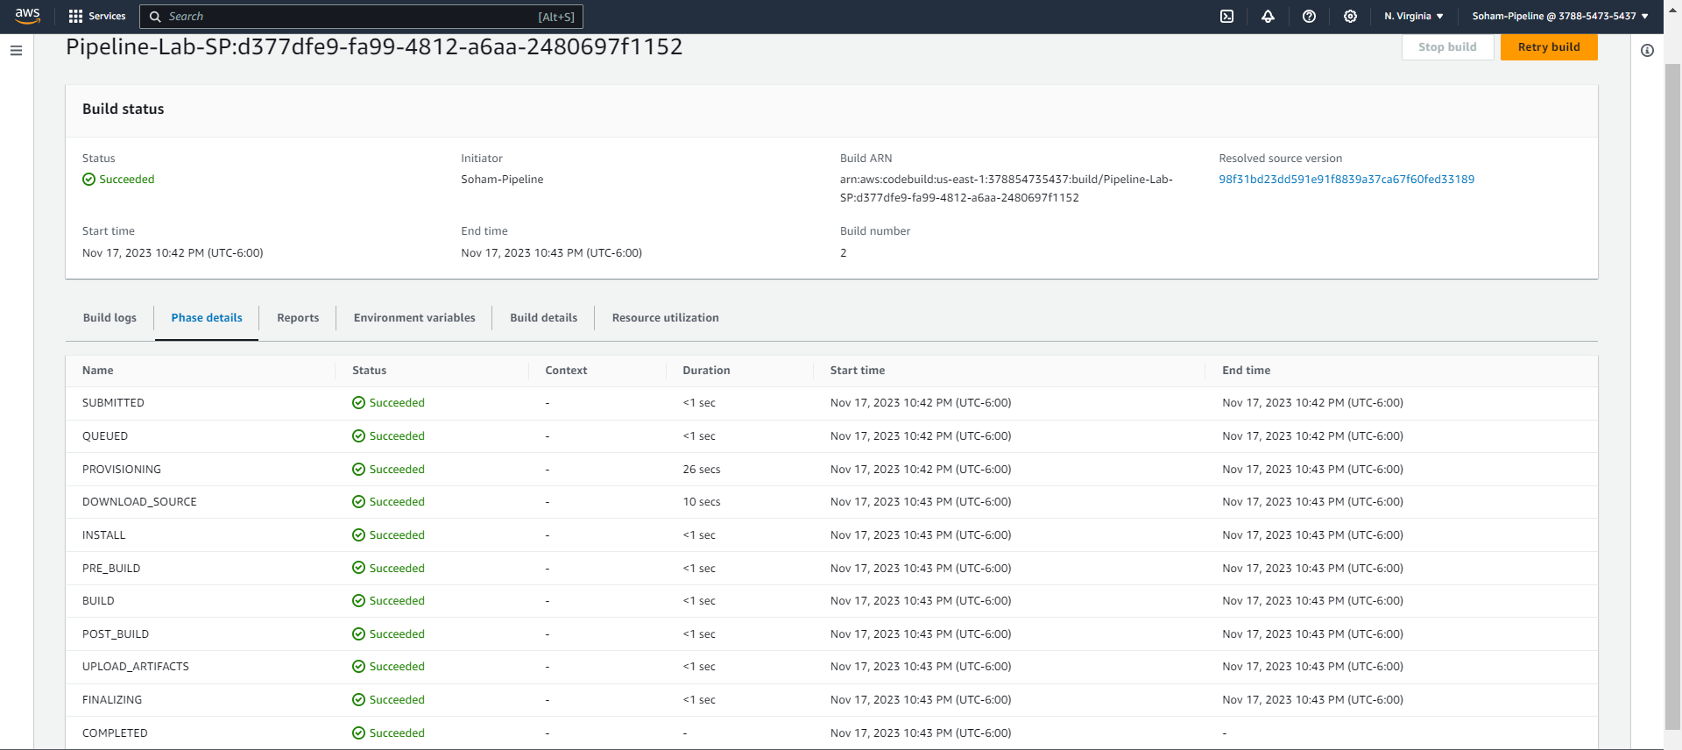

TASK 5: Check your artifact

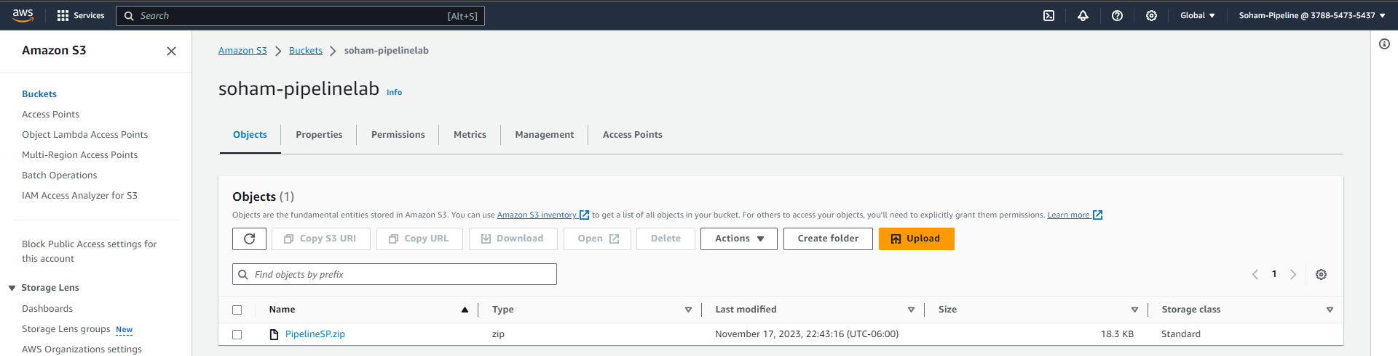

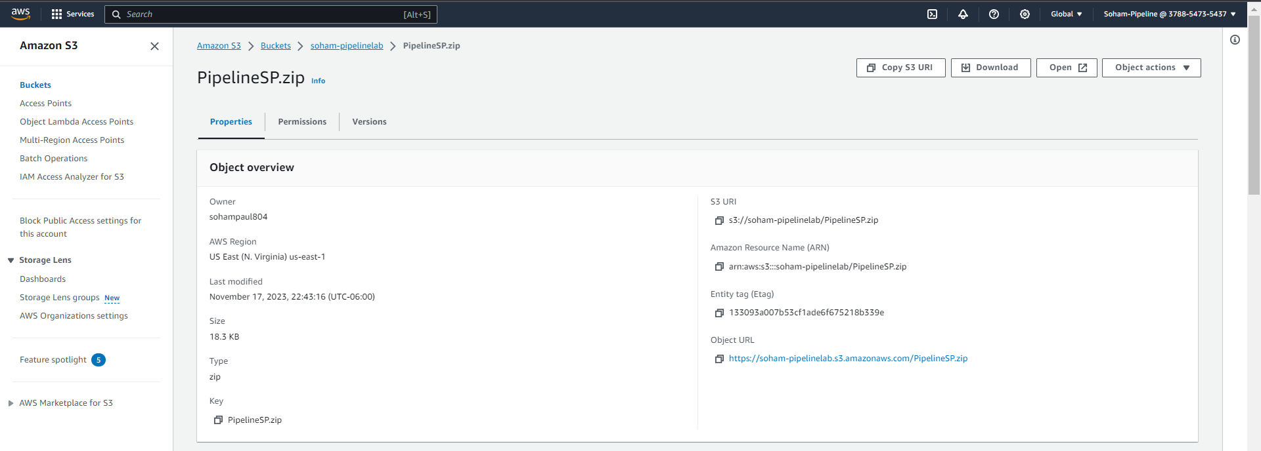

Theory question:

**Q) What is an artifact? Explain it in general as well as about this lab.**

**Ans:** An artifact is the outcome of the build process in a software project which contains the compiled or packaged code, along with all the essential dependencies, configurations, and resources required for the application's execution. These artifacts are usually generated during continuous integration or the build phase and act as the deliverables deployed to a specified target environment.

In this lab the artifact is the zip file which has been created as a part of build process and was uploaded in the S3 bucket containing the application code and the related dependencies. The AppSpec file then provides the necessary instructions for AWS CodeDeploy to correctly deploy and configure the artifacts on the target instances during the deployment process.

PART 3: CODE DEPLOY

In this lab, we will create an Elastic Beanstalk application which will be used later in the CodeDeploy stage while adding stages in the pipeline in the next part

Creating Beanstalk App

TASK: Create an Elastic Beanstalk application with PHP as your platform (Select defaults for platform branch & version) and use the application code from s3

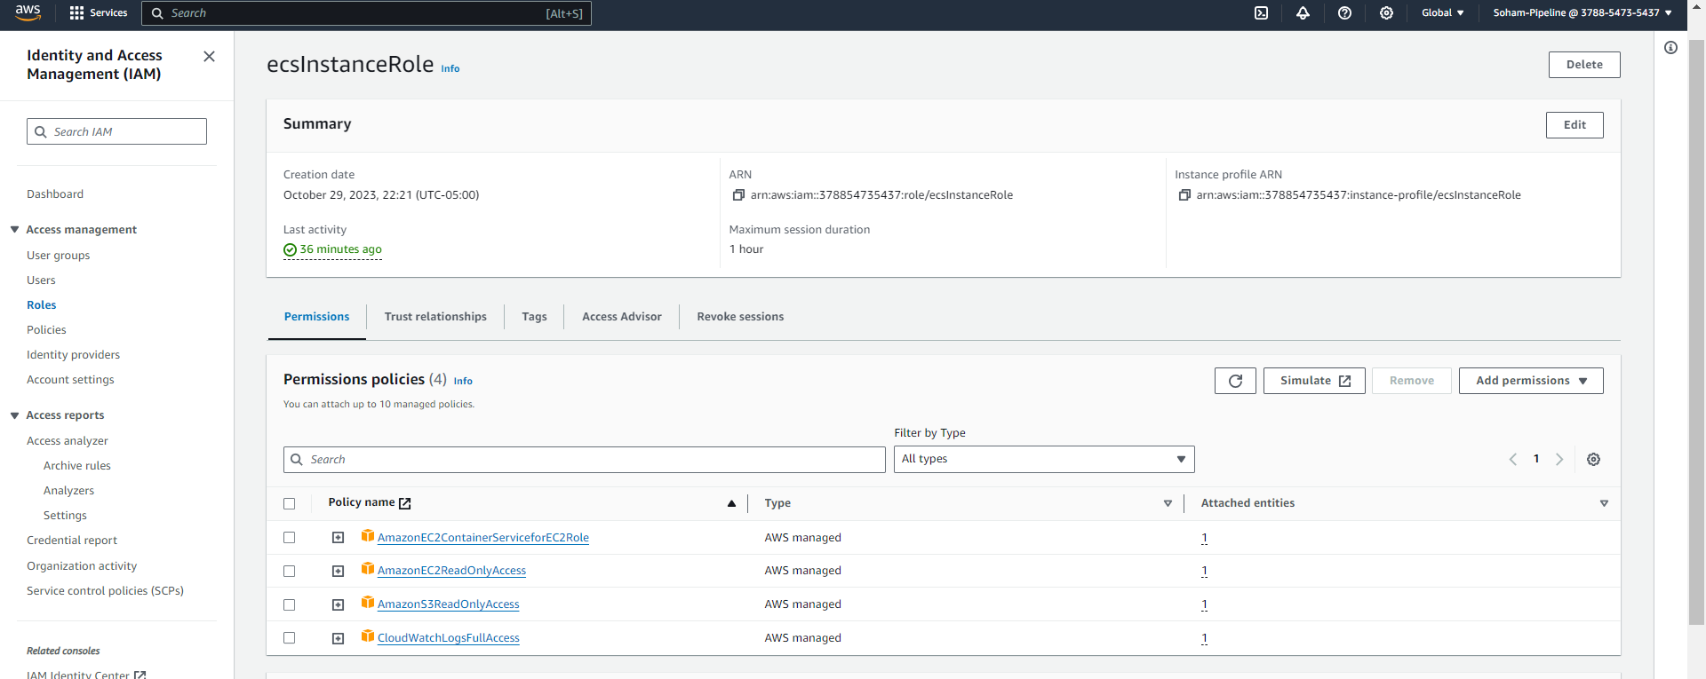

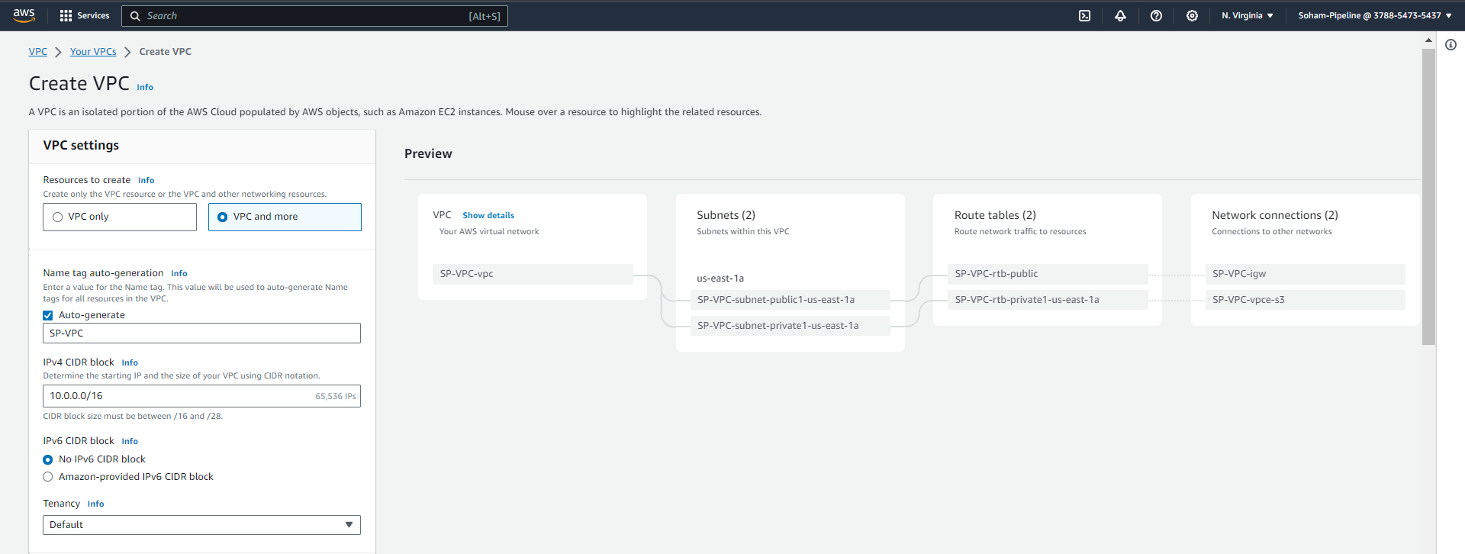

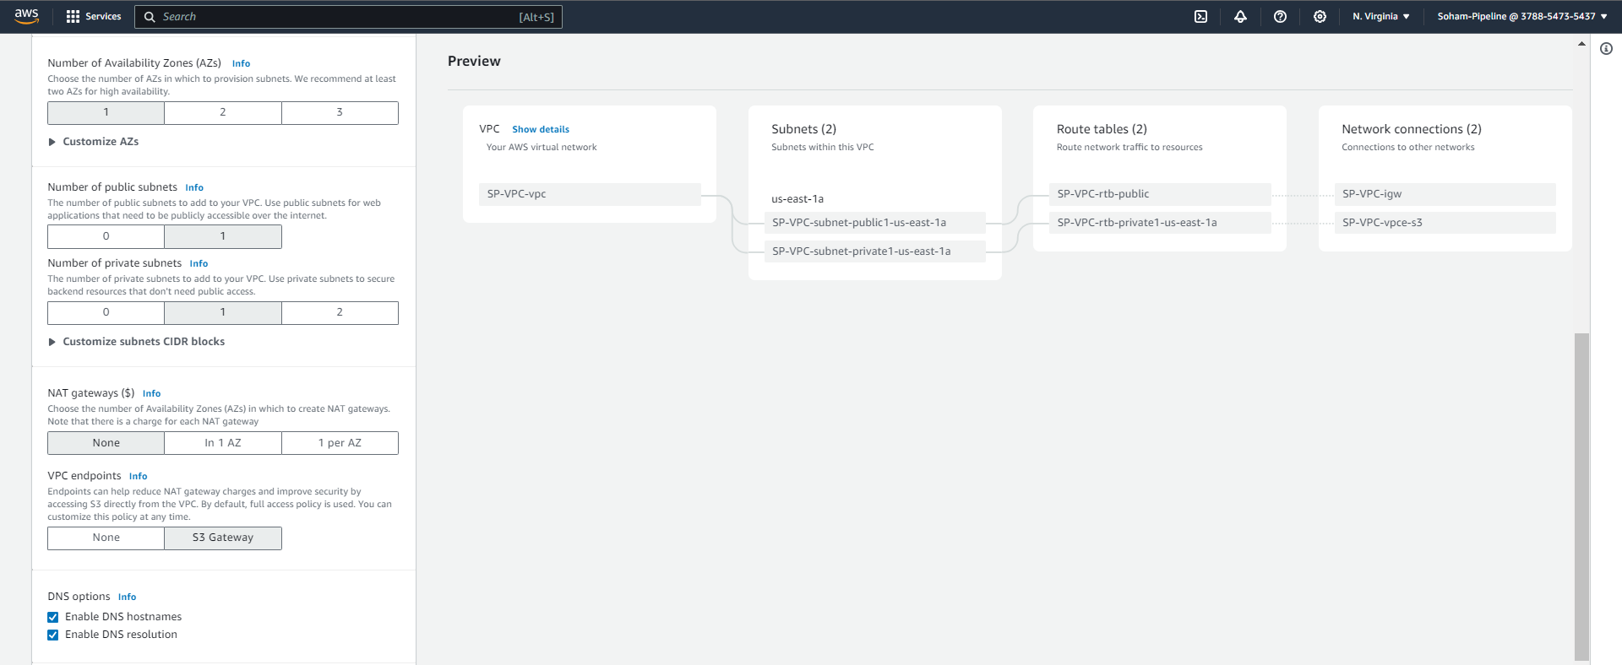

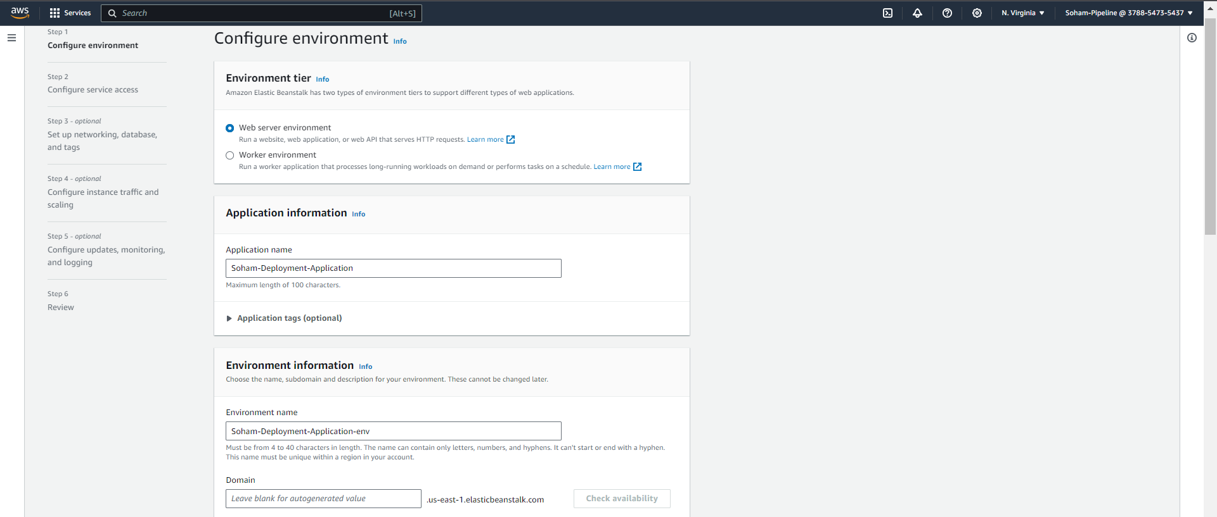

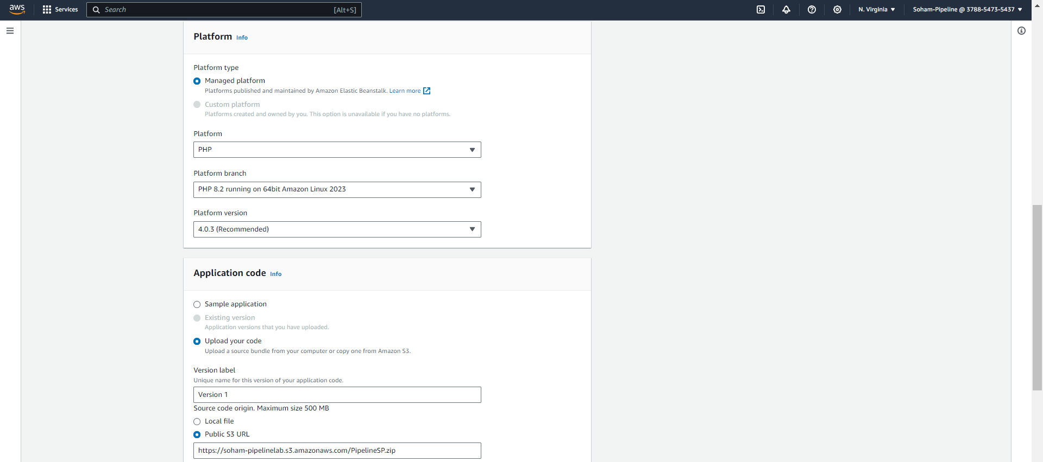

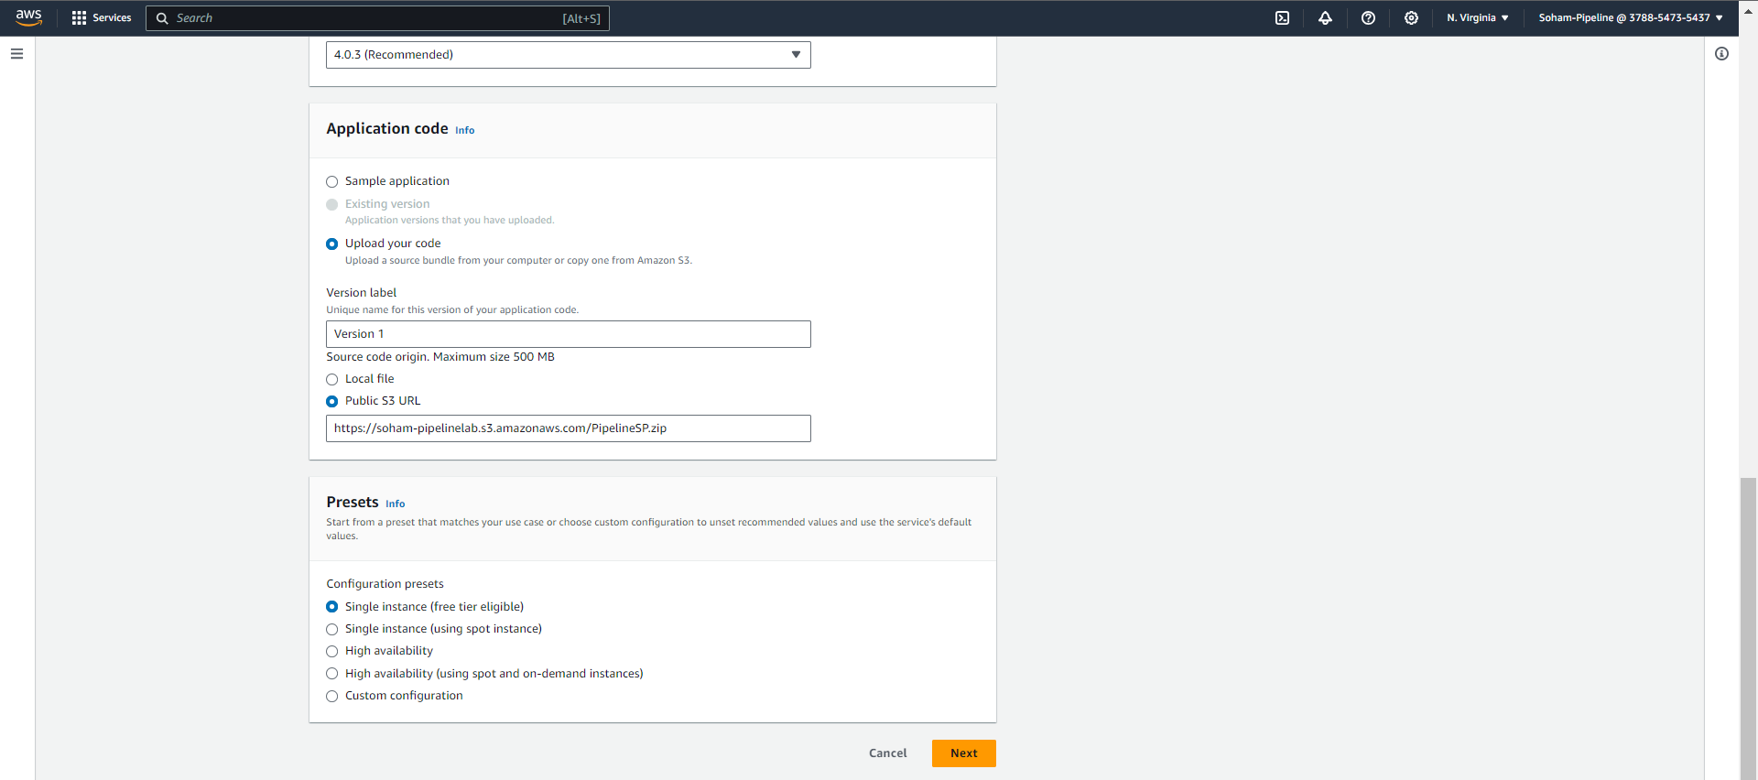

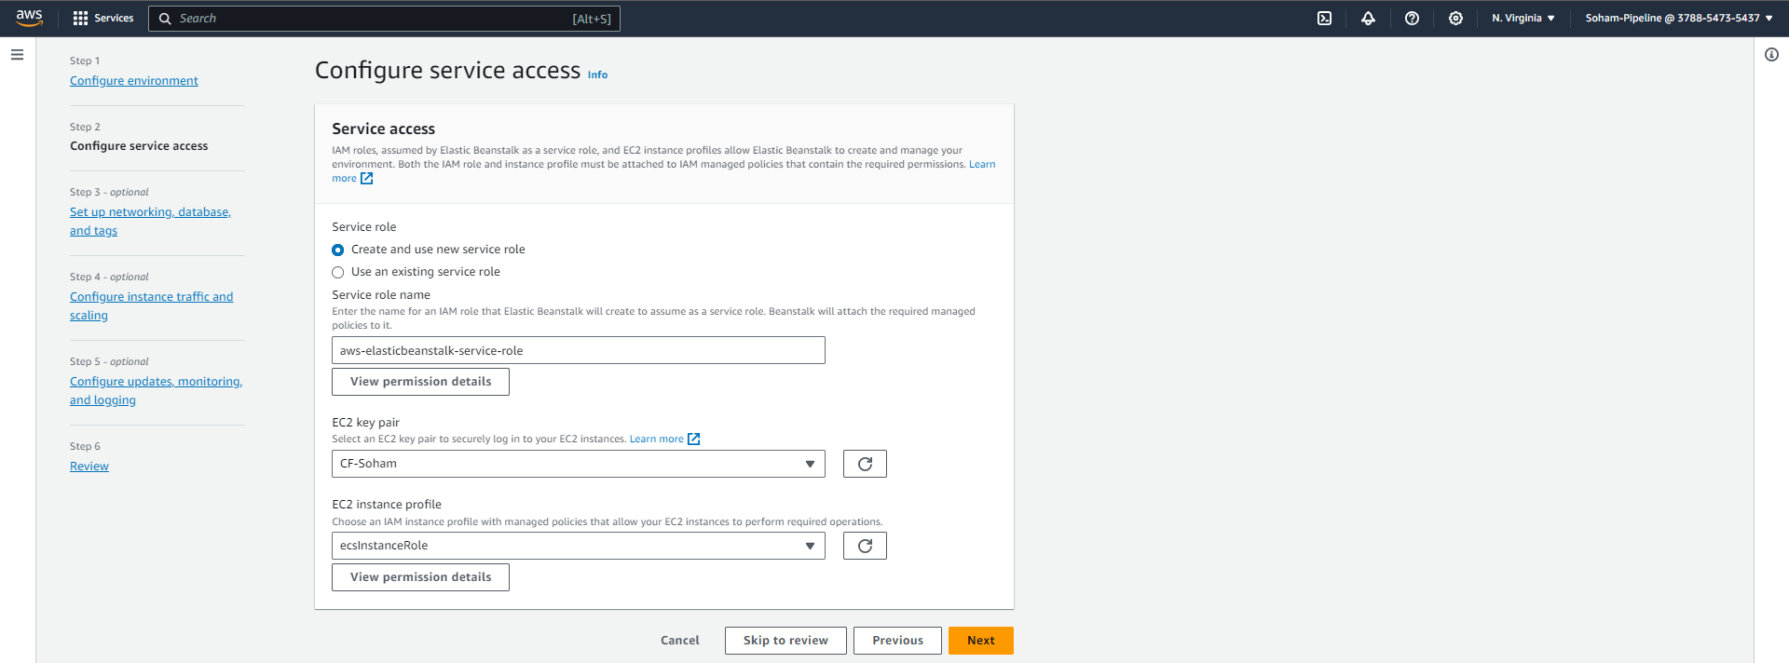

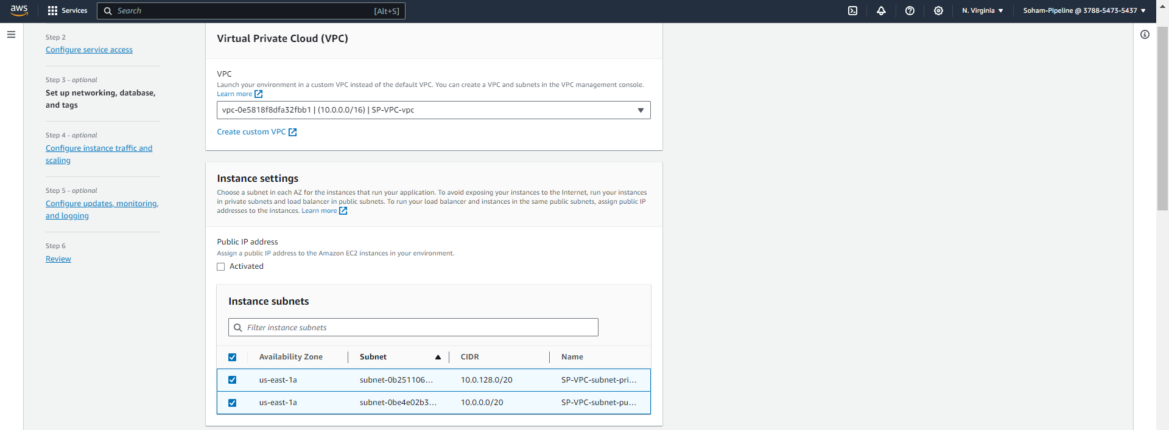

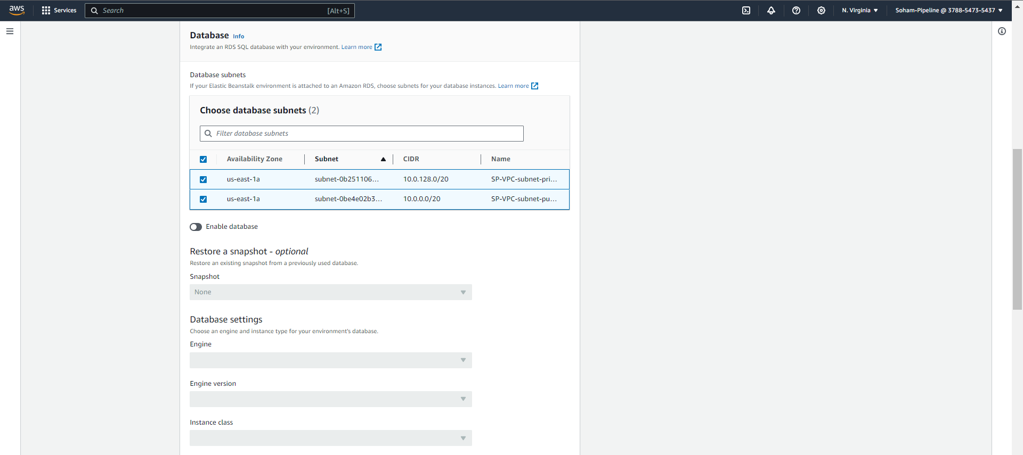

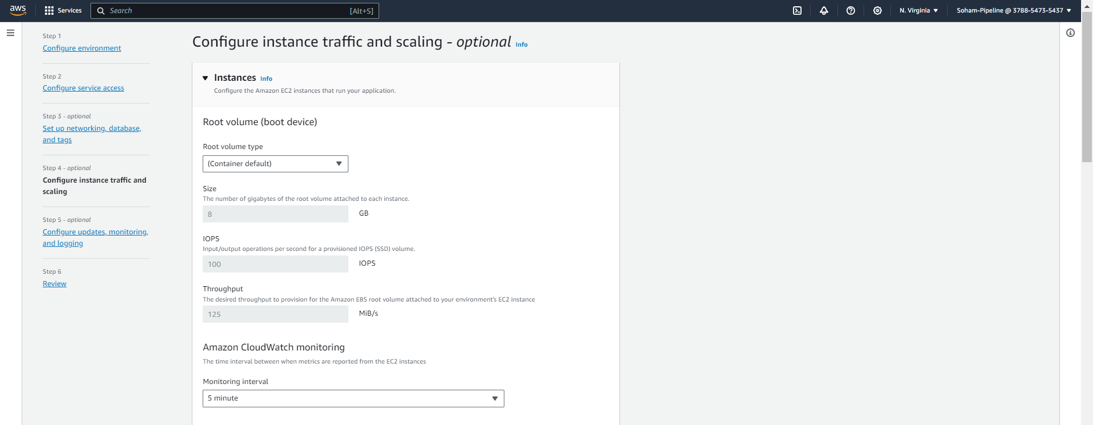

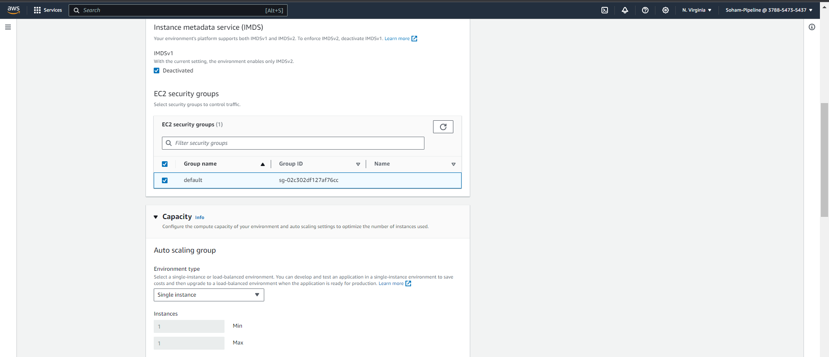

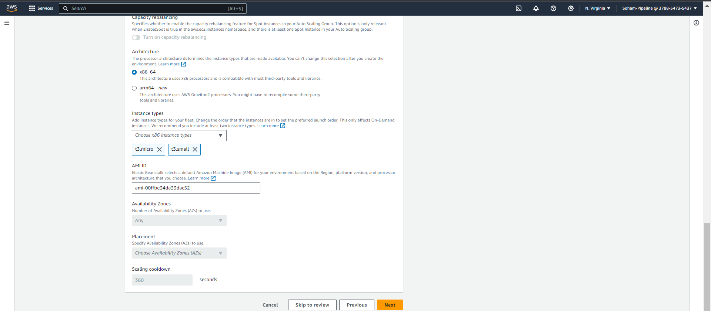

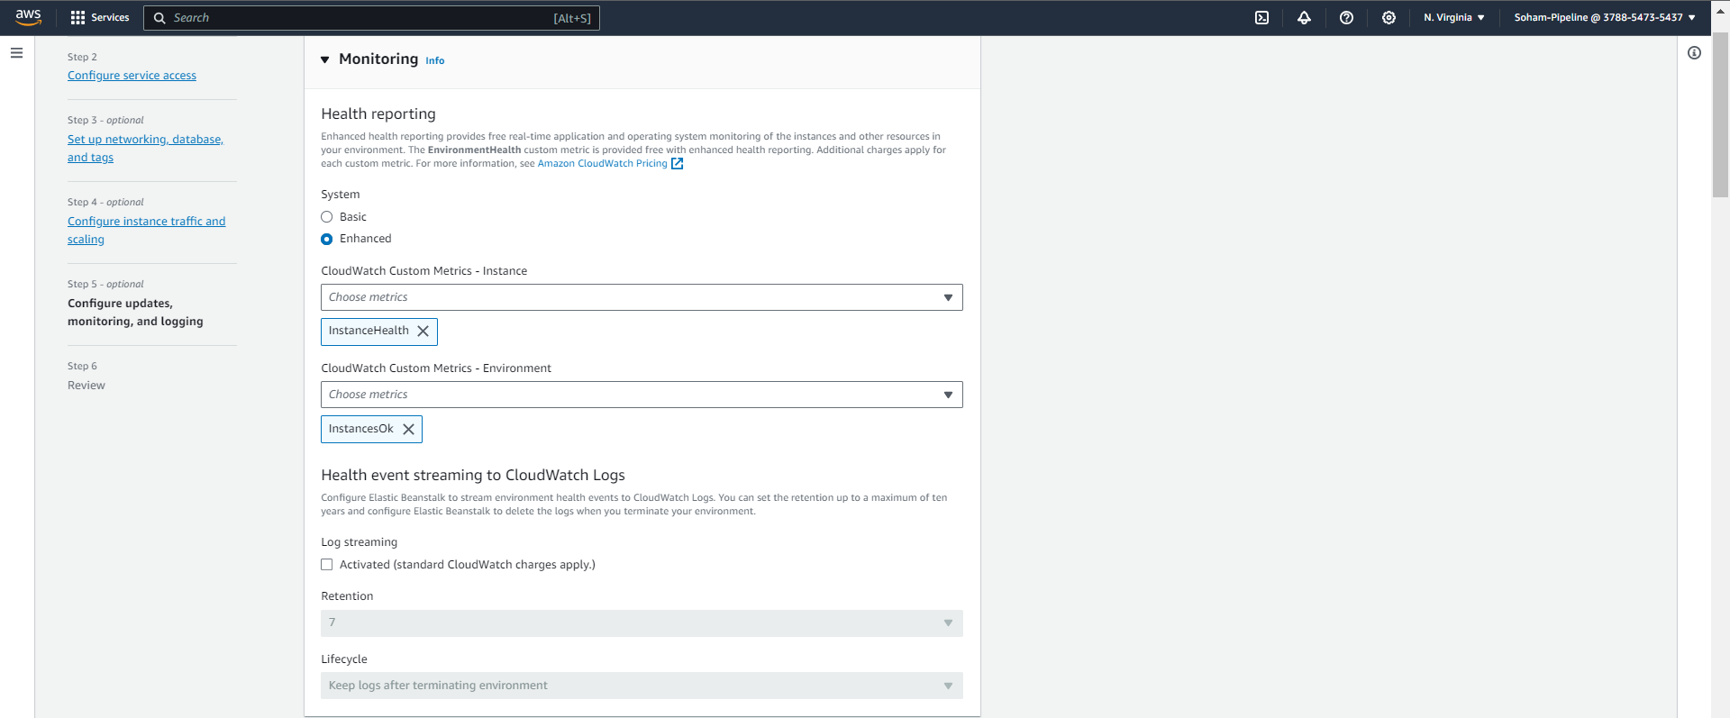

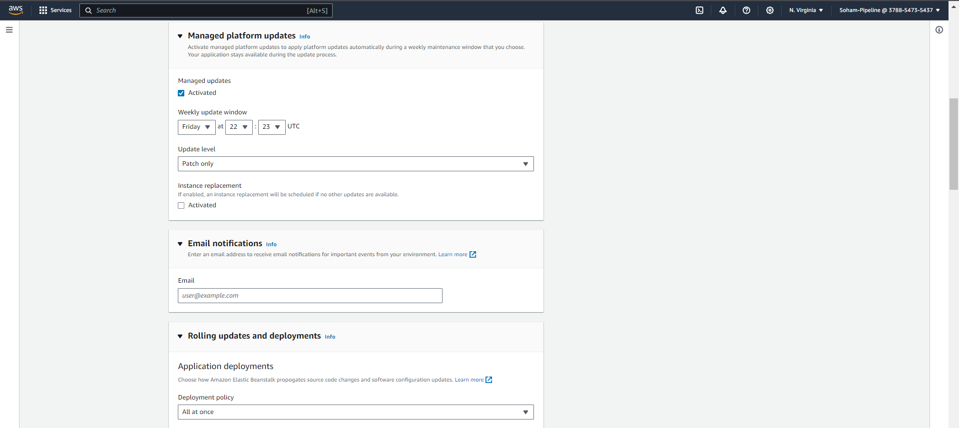

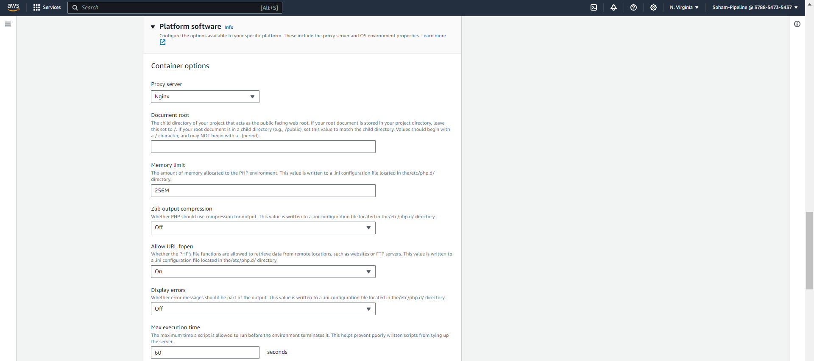

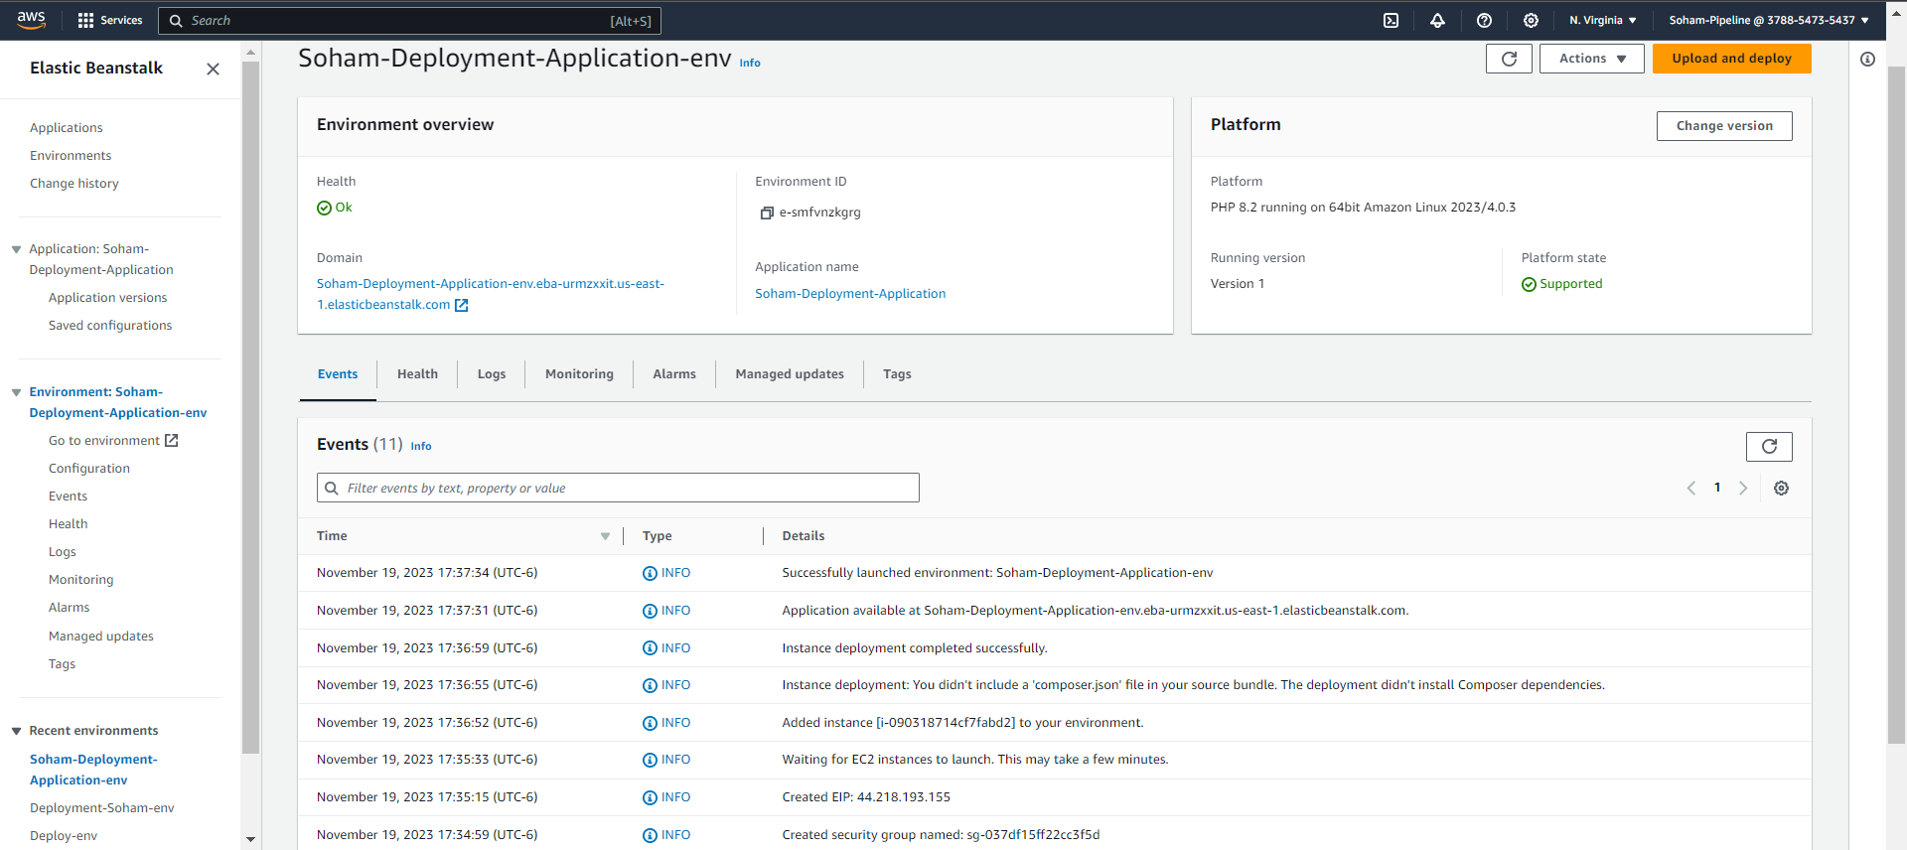

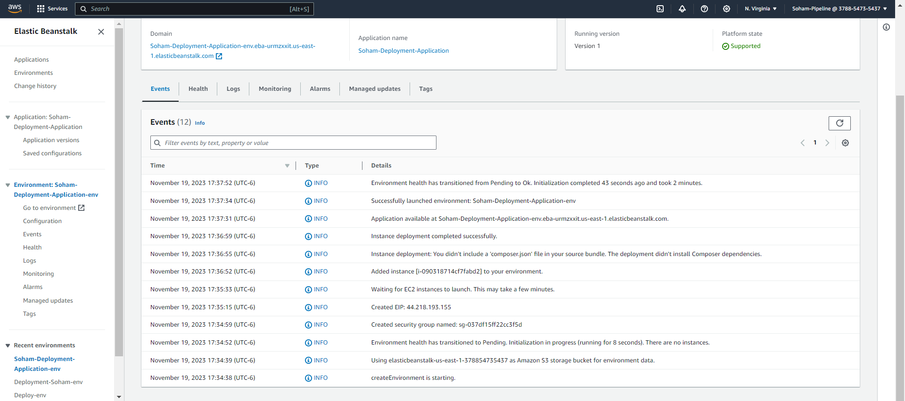

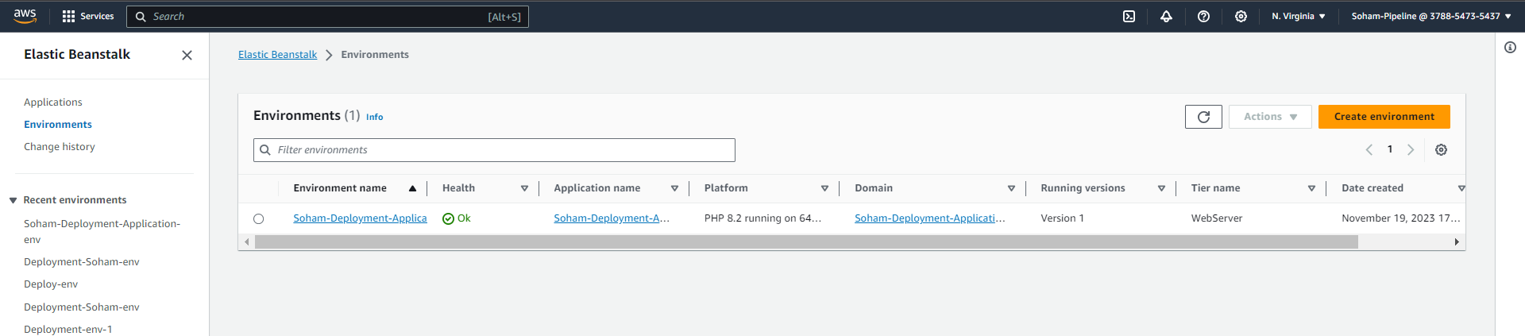

PART 4: CODE PIPELINE

Creating end to end pipeline using CodePipeline

TASK 1: In this task, now we put together all the stages that we created in parts 1, 2, and 3. Select the appropriate and correct option for each stage to build the pipeline

TASK 2: Meanwhile the pipeline is getting created, you should receive notifications from CloudWatch Alarms indicating the stages being created

TASK 3: Pipeline created

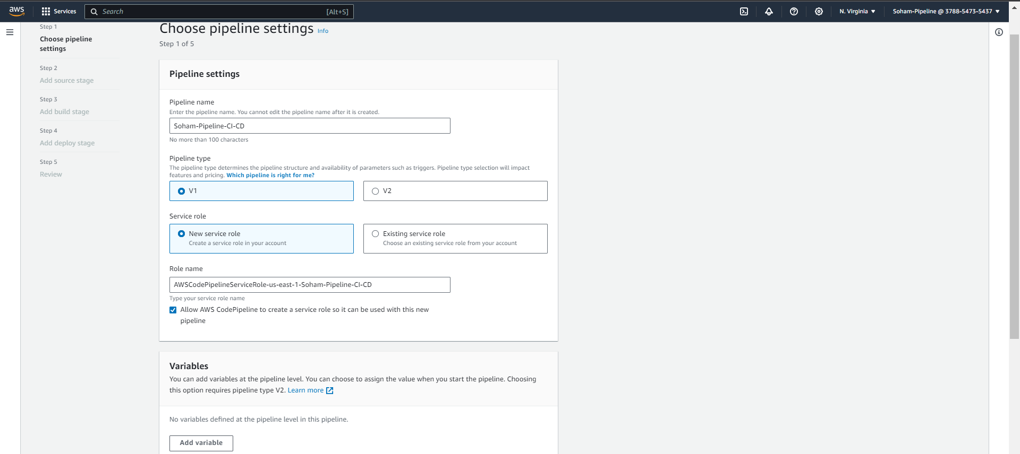

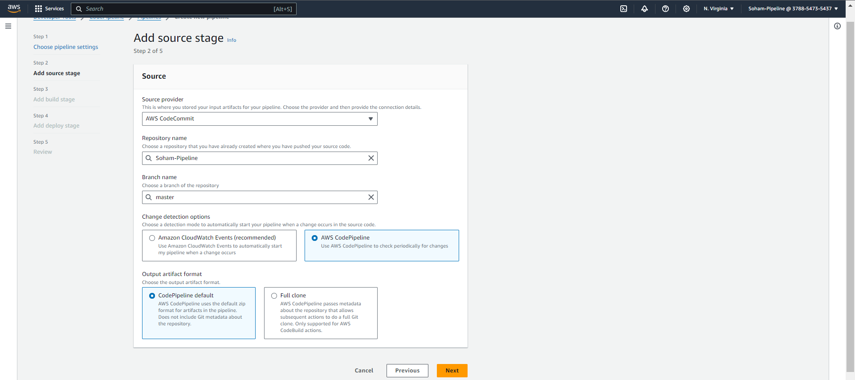

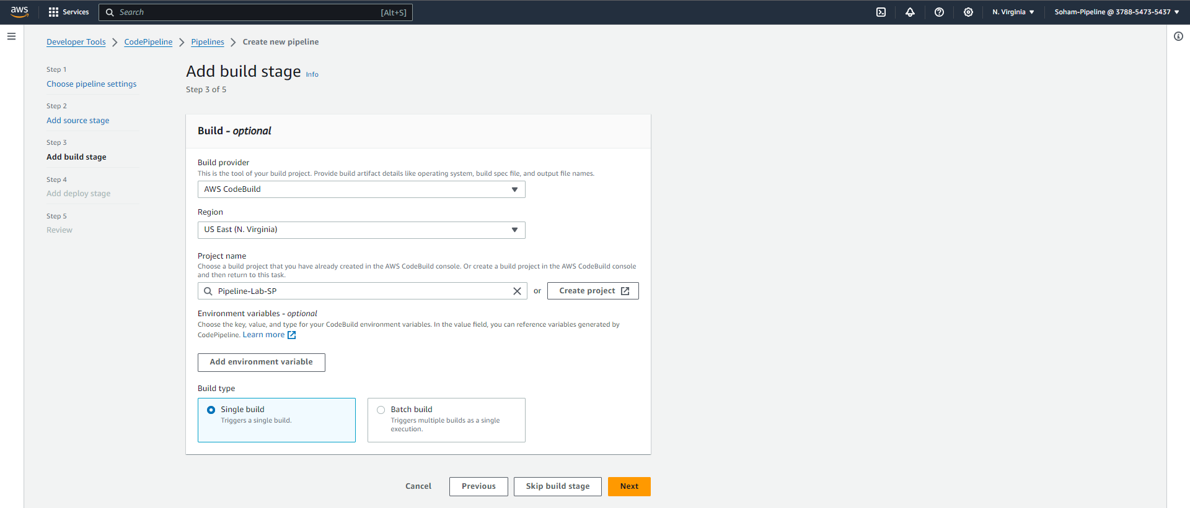

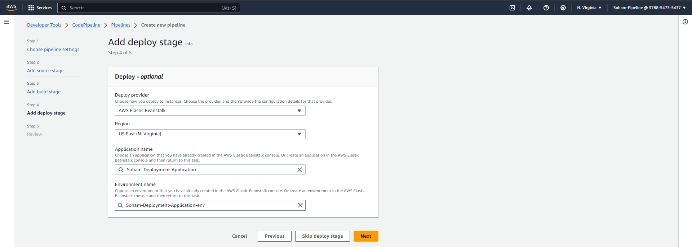

TASK 4: Check whether your pipeline is deployed successfully

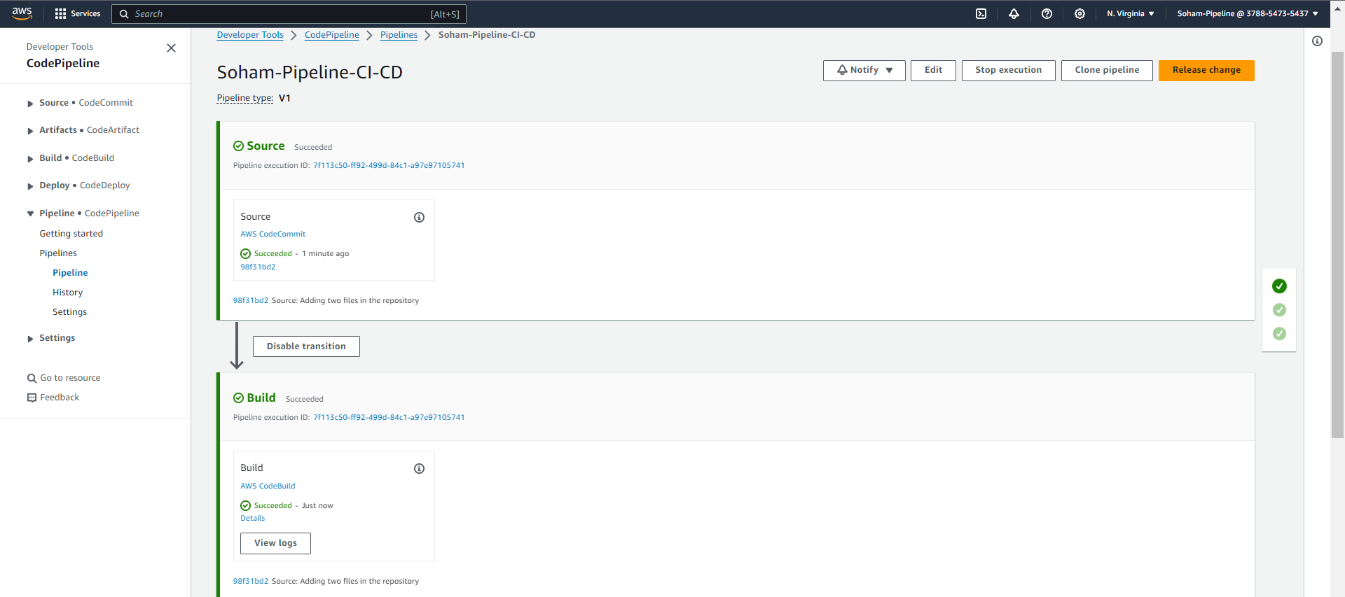

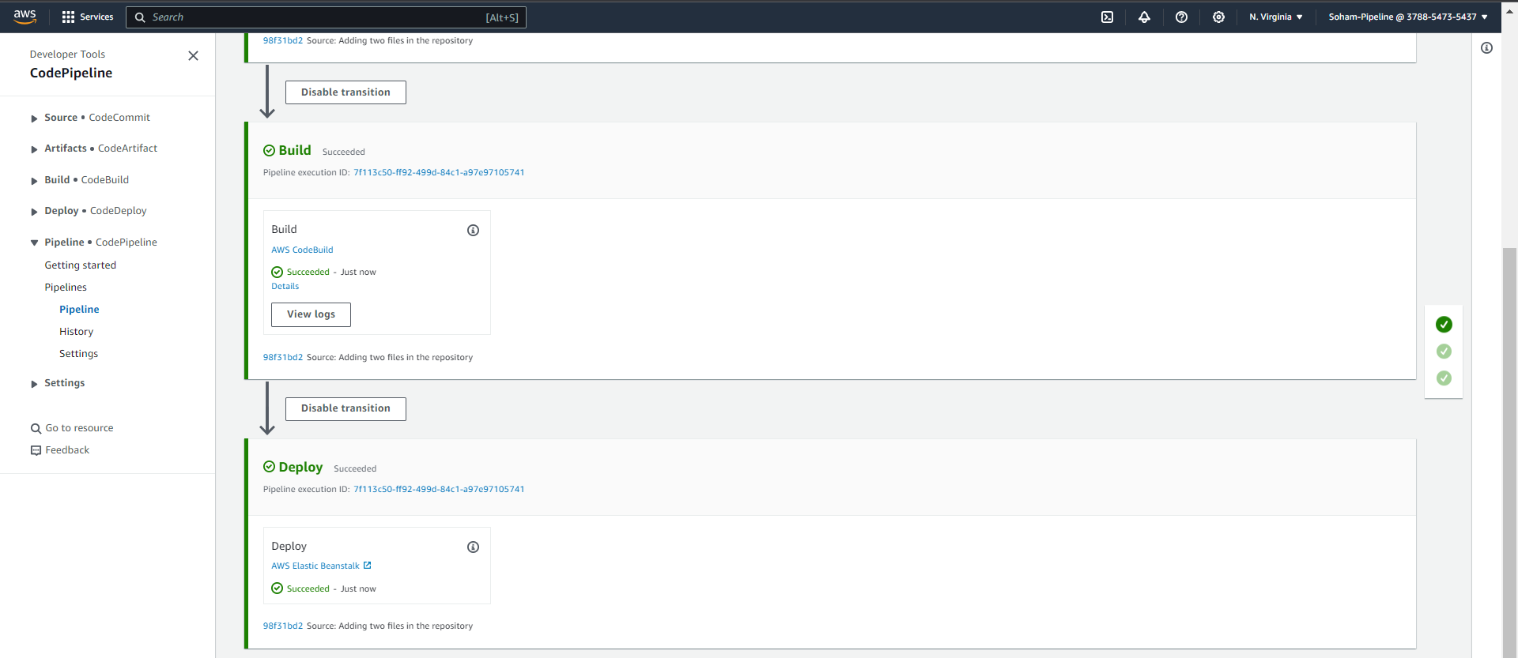

Theory question:

**Q) Explain how a pipeline works in detail**

**Ans:** A software development pipeline, commonly known as a CI/CD pipeline, is an automated mechanism crafted to streamline the software delivery process from development to production. This structured workflow comprises various stages, commencing with code integration and progressing through testing, deployment, and monitoring. Developers initiate the pipeline by committing code changes to a version control system, triggering the Continuous Integration (CI) phase. During this phase, the code undergoes automatic building, and automated tests ensure smooth integration and error-free modifications. Successfully validated code proceeds to the Continuous Deployment (CD) phase, where it is deployed across different environments, accompanied by additional tests tailored for deployment-specific issues. The pipeline automates these operations, enhancing uniformity and mitigating the risk of human errors. Developers receive timely feedback throughout the pipeline, enabling prompt identification and correction of issues. Continuous monitoring and feedback loops contribute to the overall health and quality of the software. CI/CD pipelines play a pivotal role in supporting agile development practices, hastening release cycles, and enhancing the overall reliability of software delivery. This is achieved through a well-structured and automated framework that encourages collaboration among development, testing, and operations teams.

TASK 5: Verify your deployment & check build history. (ADD SCREENSHOT)

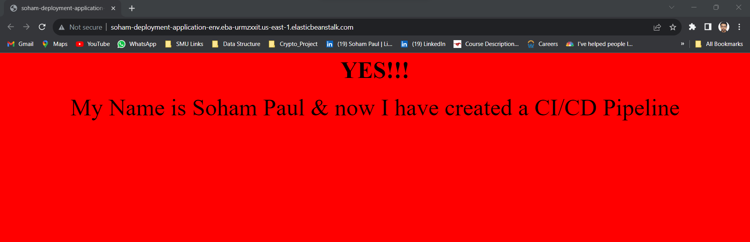

**Q) Explain how you triggered your pipeline and how the whole process of building till deploying the pipeline was done.**

**Ans:** Firstly, created a repository in CodeCommit with HTTPS and then I created a S3 bucket to save my artifacts. After that I created the important files buildspec.yaml and appspec.yaml to build the application. Along with that the html file which contains the code. Then I added those files into my github repository. After that created a CodeBuild, where I created a project to use the files I created and save it as an artifact in a zip file in my S3 bucket created earlier. Then I started the build which used the buildspec.yaml file to create the build and saved all my three files in a zip folder in S3. Then used the Elastic Beanstalk application to create the environment where I will deploy the application publically to be used from anywhere and by anyone. After that created the CI/CD pipeline to deploy the application finally. After successful deployment I can access the application using the domain URL created by Elastic Beanstalk as a part of environment creation.

___End of Lab___